**Basic JUnit Testing Exercises**

**Exercise 1: Setting Up Junit**

**Pom.xml (**added dependency)

<?xml version="1.0" encoding="UTF-8"?>  
<project xmlns="http://maven.apache.org/POM/4.0.0"  
 xmlns:xsi="http://www.w3.org/2001/XMLSchema-instance"  
 xsi:schemaLocation="http://maven.apache.org/POM/4.0.0 http://maven.apache.org/xsd/maven-4.0.0.xsd">  
 <modelVersion>4.0.0</modelVersion>  
  
 <groupId>com.example</groupId>  
 <artifactId>junittest</artifactId>  
 <version>1.0-SNAPSHOT</version>  
  
 <properties>  
 <maven.compiler.source>21</maven.compiler.source>  
 <maven.compiler.target>21</maven.compiler.target>  
 <project.build.sourceEncoding>UTF-8</project.build.sourceEncoding>  
 </properties>  
 <dependencies>  
 <dependency>  
 <groupId>junit</groupId>  
 <artifactId>junit</artifactId>  
 <version>4.13.2</version>  
 <scope>test</scope>  
 </dependency>  
 </dependencies>  
</project>

**Calculator.java**(created test class)

package com.example;  
  
public class Calculator {  
 public int add(int a, int b) {  
 return a + b;  
 }  
}

**OUTPUT**

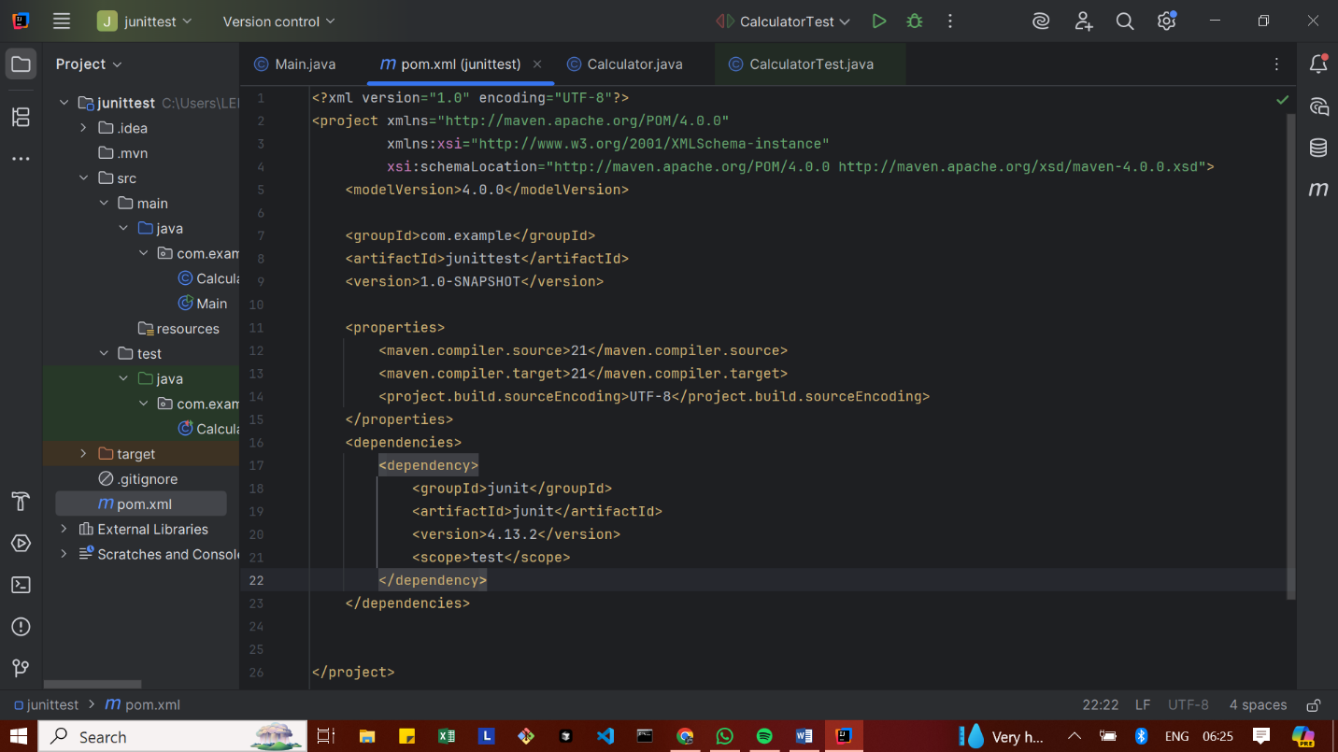

**Exercise 2: Writing Basic JUnit Tests**

src/main/java/com/example/Calculator

Calculator.java

package com.example;  
  
public class Calculator {  
 public int add(int a, int b) {  
 return a + b;  
 }  
}

src/test/java/com/example/CalculatorTest

CalculatorTest.java

package com.example;  
  
import org.junit.Test;  
import static org.junit.Assert.*;  
  
public class CalculatorTest {  
  
 @Test  
 public void testAdd() {  
 Calculator calc = new Calculator();  
 int result = calc.add(2, 3);  
 *assertEquals*(5, result);  
 }  
}

**OUTPUT**

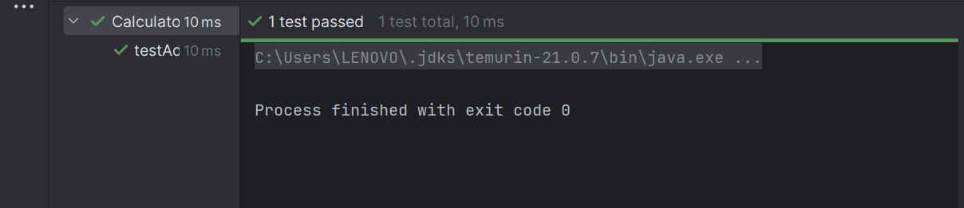

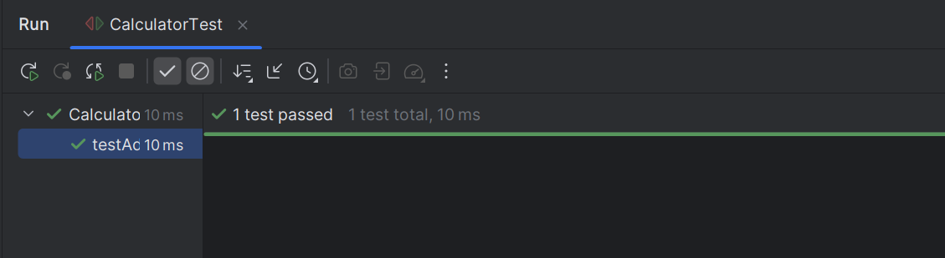

**Exercise 3: Assertions in Junit**

Calculator.java

package com.example;  
  
import org.junit.Test;  
import static org.junit.Assert.*;  
  
public class CalculatorTest {  
  
 @Test  
 public void testAssertions() {  
  
 *assertEquals*(5, 3 + 2);  
  
  
 *assertTrue*(5 > 3);  
  
  
 *assertFalse*(5 < 3);  
  
  
 Object obj1 = null;  
 *assertNull*(obj1);  
  
  
 Object obj2 = new Object();  
 *assertNotNull*(obj2);  
 }  
}

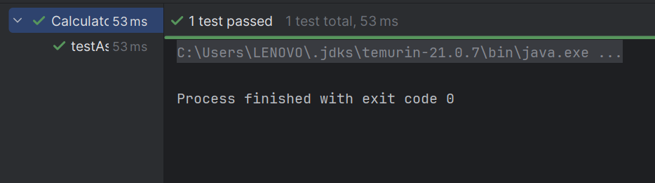

**Exercise 4: Arrange-Act-Assert (AAA) Pattern, Test Fixtures, Setup and Teardown Methods in Junit**

Calculator.java

package com.example;  
  
public class Calculator {  
 public int add(int a, int b) {  
 return a + b;  
 }  
  
 public int multiply(int a, int b) {  
 return a * b;  
 }  
}

CalculatorTest.java

package com.example;  
  
import org.junit.After;  
import org.junit.Before;  
import org.junit.Test;  
  
import static org.junit.Assert.*;  
  
public class CalculatorTest {  
  
 private Calculator calc;  
  
  
 @Before  
 public void setUp() {  
 System.*out*.println("Setting up calculator...");  
 calc = new Calculator(); // ARRANGE  
 }  
  
  
 @After  
 public void tearDown() {  
 System.*out*.println("Cleaning up...");  
 calc = null;  
 }  
  
 @Test  
 public void testAdd() {  
  
 int result = calc.add(2, 3);  
  
 *assertEquals*(5, result);  
 }  
  
 @Test  
 public void testMultiply() {  
 int result = calc.multiply(4, 5);  
 *assertEquals*(20, result);  
 }  
}

**OUTPUT**

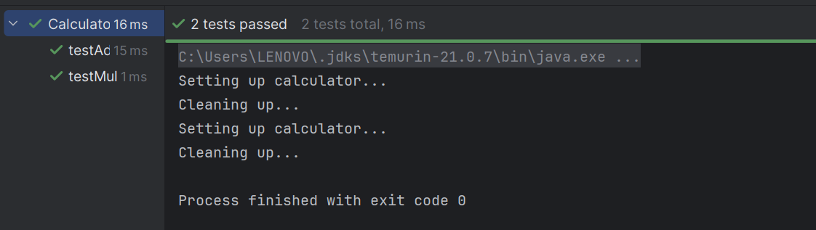

**Advanced JUnit Testing Exercises**

**Exercise 1: Parameterized Tests**

EvenChecker.java

package com.example;  
  
public class EvenChecker {  
 public static boolean isEven(int number) {  
 return number % 2 == 0;  
 }  
}

EvenCheckerTest.java

package com.example;  
  
import org.junit.jupiter.params.ParameterizedTest;  
import org.junit.jupiter.params.provider.ValueSource;  
import static org.junit.jupiter.api.Assertions.*;  
  
class EvenCheckerTest {  
  
 @ParameterizedTest  
 @ValueSource(ints = {2, 4, 6, 8, 10})  
 void testEvenNumbers(int number) {  
 *assertTrue*(EvenChecker.*isEven*(number));  
 }  
  
 @ParameterizedTest  
 @ValueSource(ints = {1, 3, 5, 7, 9})  
 void testOddNumbers(int number) {  
 *assertFalse*(EvenChecker.*isEven*(number));  
 }  
}

**OUTPUT**

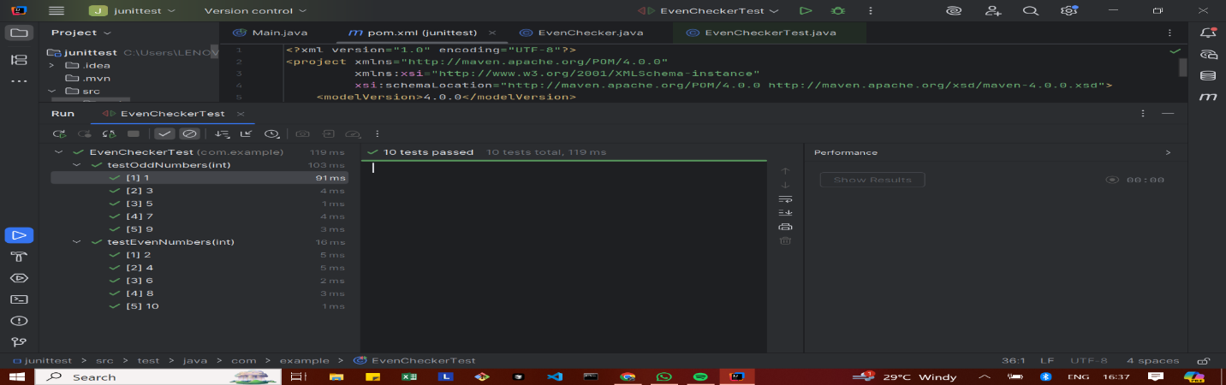

**Exercise 2: Test Suites and Categories**

CalculatorTest.java

package com.example;  
  
import org.junit.jupiter.api.Test;  
import static org.junit.jupiter.api.Assertions.*;  
  
public class CalculatorTest {  
  
 @Test  
 void testAddition() {  
 *assertEquals*(5, 2 + 3);  
 }  
}

EvenCheckerTest.java

package com.example;  
  
import org.junit.jupiter.params.ParameterizedTest;  
import org.junit.jupiter.params.provider.ValueSource;  
  
import static org.junit.jupiter.api.Assertions.*;  
  
public class EvenCheckerTest {  
  
 @ParameterizedTest  
 @ValueSource(ints = {2, 4, 6})  
 void testEven(int number) {  
 *assertTrue*(number % 2 == 0);  
 }  
}

AllTests.java

package com.example;  
  
import org.junit.platform.suite.api.SelectClasses;  
import org.junit.platform.suite.api.Suite;  
  
@Suite  
@SelectClasses({  
 CalculatorTest.class,  
 EvenCheckerTest.class  
})  
public class AllTests {  
}

**OUTPUT**

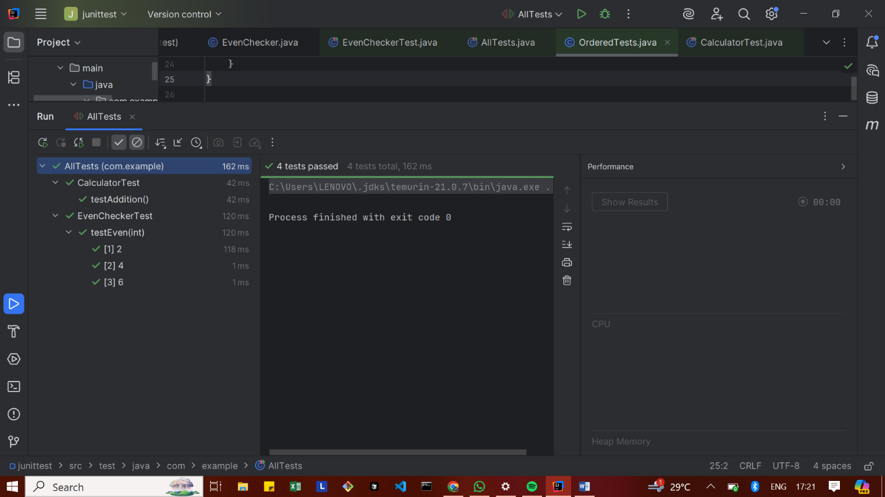

**Exercise 3: Test Execution Order**

OrderedTests.java

package com.example;  
  
import org.junit.jupiter.api.*;  
  
@TestMethodOrder(MethodOrderer.OrderAnnotation.class)  
public class OrderedTests {  
  
 @Test  
 @Order(1)  
 void testLogin() {  
 System.*out*.println("1️⃣ testLogin executed");  
 }  
  
 @Test  
 @Order(3)  
 void testLogout() {  
 System.*out*.println("3️⃣ testLogout executed");  
 }  
  
 @Test  
 @Order(2)  
 void testDashboard() {  
 System.*out*.println("2️⃣ testDashboard executed");  
 }  
}

**OUTPUT**

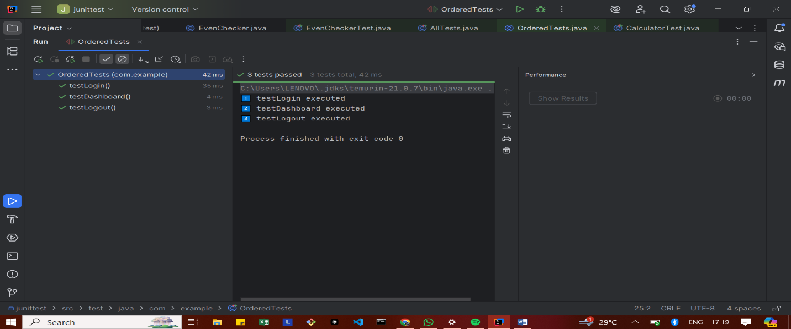

**Exercise 4: Exception Testing**

ExceptionThrower.java

package com.example;  
  
public class ExceptionThrower {  
  
 public void throwException() {  
 throw new IllegalArgumentException("This is an illegal argument!");  
 }  
}

ExceptionThrowerTest.java

package com.example;  
  
import org.junit.jupiter.api.Test;  
import static org.junit.jupiter.api.Assertions.*;  
  
public class ExceptionThrowerTest {  
  
 @Test  
 void testExceptionThrown() {  
 ExceptionThrower et = new ExceptionThrower();  
  
  
 Exception exception = *assertThrows*(IllegalArgumentException.class, et::throwException);  
  
  
 *assertEquals*("This is an illegal argument!", exception.getMessage());  
 }  
}

**OUTPUT**

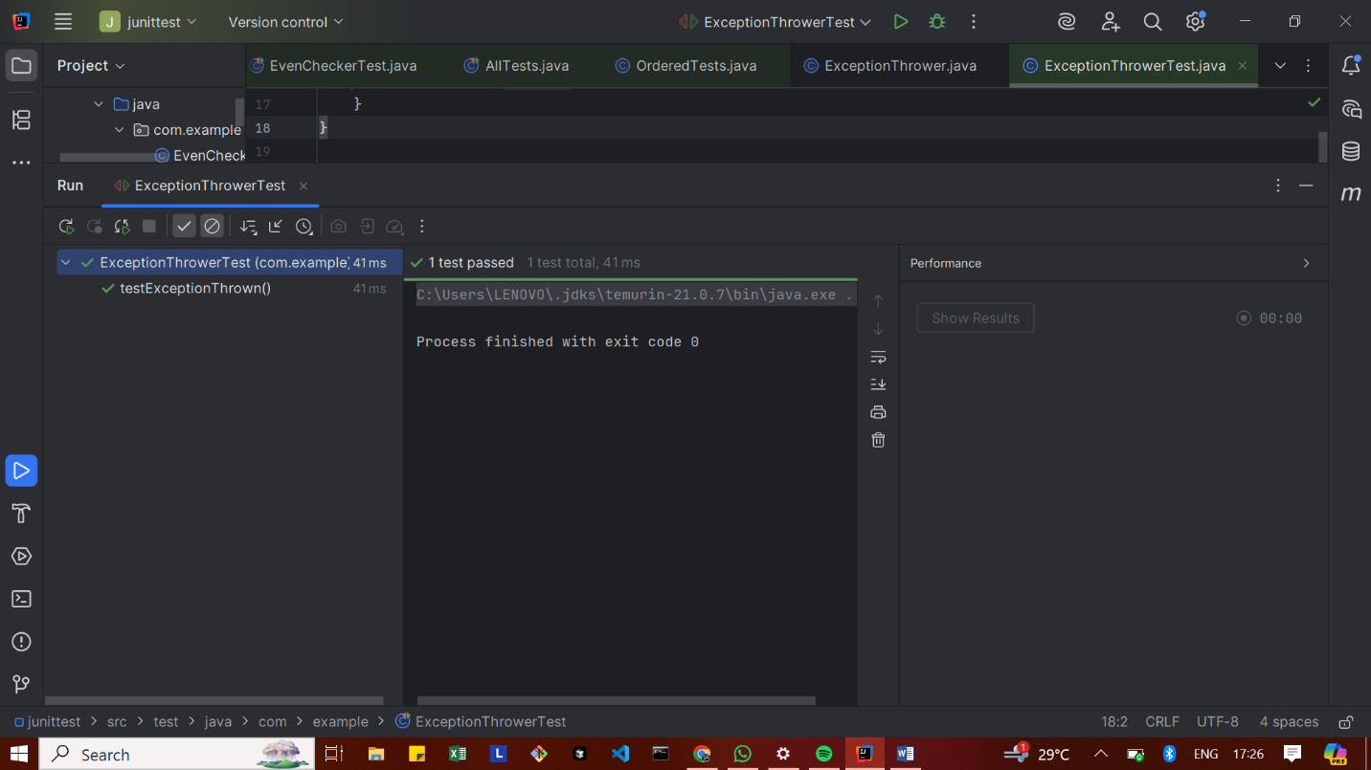

**Exercise 5: Timeout and Performance Testing**

PerformanceTester.java

package com.example;  
  
public class PerformanceTester {  
  
 public void performTask() {  
 try {  
 // Simulate a time-consuming task (e.g., 500ms)  
 Thread.*sleep*(500);  
 } catch (InterruptedException e) {  
 e.printStackTrace();  
 }  
 }  
}

PerformanceTesterTest.java

package com.example;  
  
import org.junit.jupiter.api.Test;  
import static org.junit.jupiter.api.Assertions.*assertTimeout*;  
import java.time.Duration;  
  
public class PerformanceTesterTest {  
  
 @Test  
 void testPerformTaskWithinTimeout() {  
 PerformanceTester tester = new PerformanceTester();  
  
 // ✅ Test should complete within 1 second (1000 milliseconds)  
 *assertTimeout*(Duration.*ofMillis*(1000), tester::performTask);  
 }  
}

**OUTPUT**

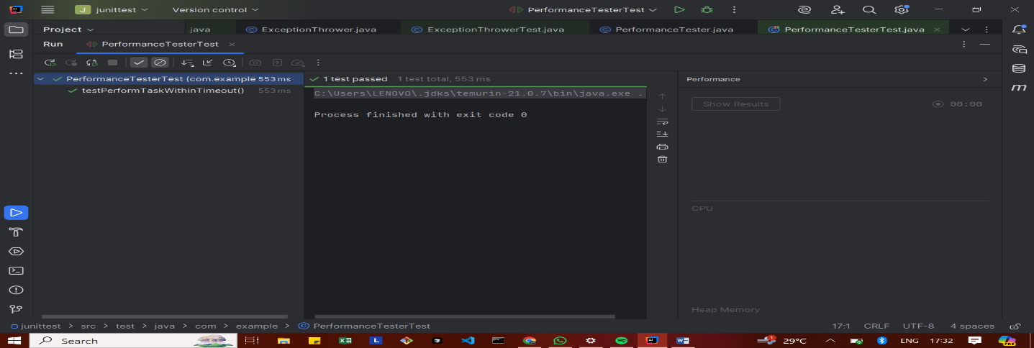

**Mockito Hands-On Exercises**

**Exercise 1: Mocking and Stubbing**

ExternalApi.java

package com.example;  
  
public interface ExternalApi {  
 String getData();  
}

MyService.java

package com.example;  
  
public class MyService {  
 private ExternalApi api;  
  
 public MyService(ExternalApi api) {  
 this.api = api;  
 }  
  
 public String fetchData() {  
 return api.getData();  
 }  
}

MyServiceTest.java

package com.example;  
  
public class MyService {  
 private ExternalApi api;  
  
 public MyService(ExternalApi api) {  
 this.api = api;  
 }  
  
 public String fetchData() {  
 return api.getData();  
 }  
}

**OUTPUT**

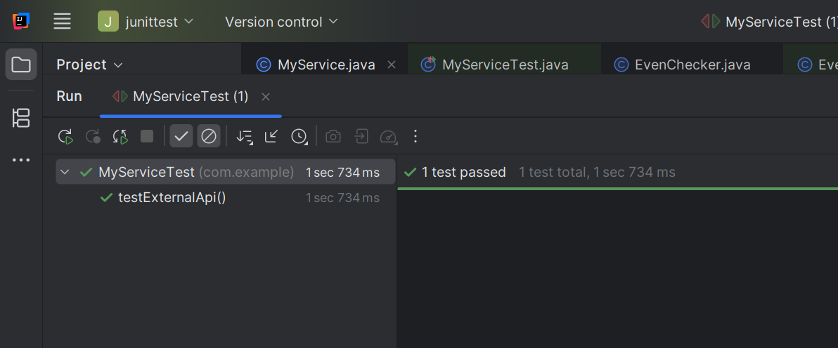

**Exercise 2: Verifying Interactions**

ExternalApi.java

package com.example;  
  
public interface ExternalApi {  
 String getData();  
}

MyService.java

package com.example;  
  
public class MyService {  
 private final ExternalApi api;  
  
 public MyService(ExternalApi api) {  
 this.api = api;  
 }  
  
 public String fetchData() {  
 return api.getData();  
 }  
}

MyServiceTest.java

package com.example;  
  
import org.junit.jupiter.api.Test;  
import static org.mockito.Mockito.*;  
  
public class MyServiceTest {  
  
 @Test  
 public void testVerifyInteraction() {  
 ExternalApi mockApi = *mock*(ExternalApi.class);  
 MyService service = new MyService(mockApi);  
 service.fetchData();  
 *verify*(mockApi).getData();  
 }  
}

**OUTPUT**

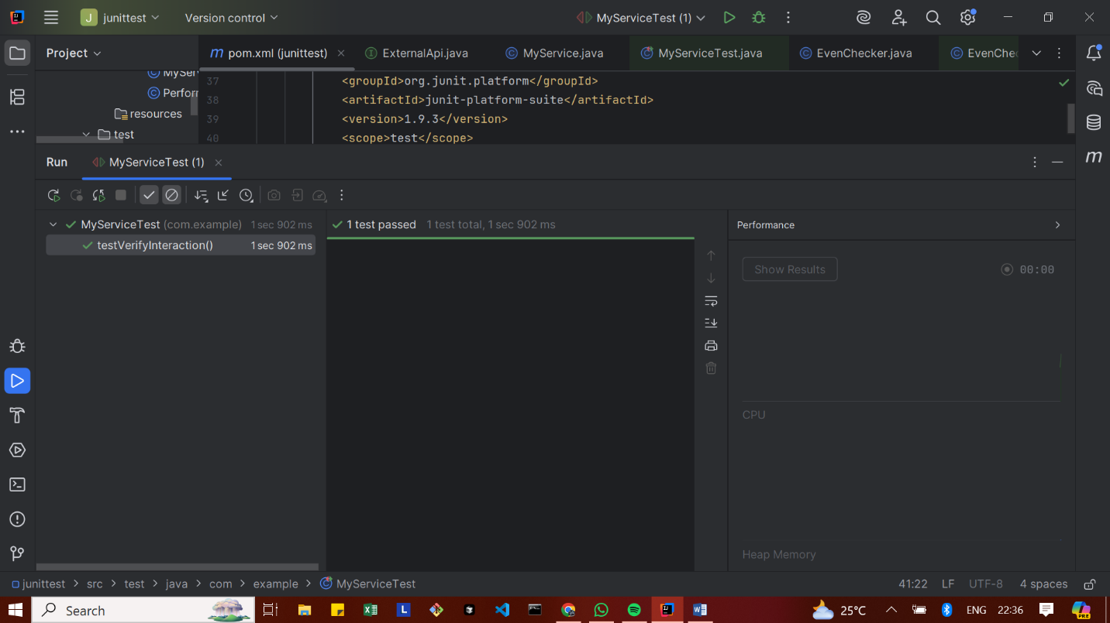

**Exercise 3: Argument Matching**

Notifier.java

// File: Notifier.java  
package com.example;  
  
public interface Notifier {  
 void send(String message);  
}

AlertService.java

// File: AlertService.java  
package com.example;  
  
public class AlertService {  
 private Notifier notifier;  
  
 public AlertService(Notifier notifier) {  
 this.notifier = notifier;  
 }  
  
 public void alertUser() {  
 notifier.send("ALERT: Something went wrong!");  
 }  
}

AlertServiceTest.java

// File: AlertServiceTest.java  
package com.example;  
  
import org.junit.jupiter.api.Test;  
import static org.mockito.Mockito.*;  
import static org.mockito.ArgumentMatchers.*;  
  
public class AlertServiceTest {  
  
 @Test  
 public void testAlertUserSendsCorrectMessage() {  
 Notifier mockNotifier = *mock*(Notifier.class);  
 AlertService alertService = new AlertService(mockNotifier);  
  
 alertService.alertUser();  
  
 // Verify that the send method was called with the expected message  
 *verify*(mockNotifier).send(*eq*("ALERT: Something went wrong!"));  
 }  
}

**OUTPUT**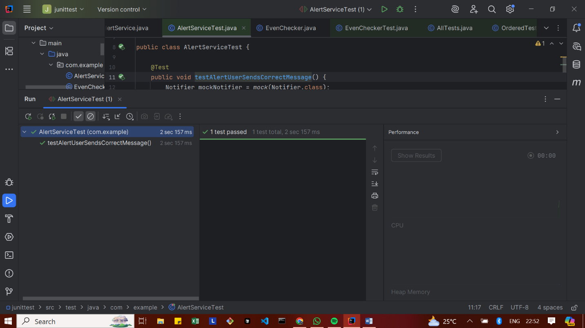

**Exercise 4: Handling Void Methods**

Notifier.java

package com.example;  
  
public interface Notifier {  
 void send(String message); // void method  
}

AlertService.java

package com.example;  
  
public class AlertService {  
 private Notifier notifier;  
  
 public AlertService(Notifier notifier) {  
 this.notifier = notifier;  
 }  
  
 public void sendAlert(String message) {  
 notifier.send(message); // void call  
 }  
}

AlertServiceTest.java

package com.example;  
  
import org.junit.jupiter.api.Test;  
import static org.mockito.Mockito.*;  
import static org.mockito.Mockito.*times*;  
  
public class AlertServiceTest {  
  
 @Test  
 public void testVoidMethodUsingVerify() {  
 // Step 1: Create mock  
 Notifier mockNotifier = *mock*(Notifier.class);  
  
 // Step 2: Stub the void method (optional if just verifying)  
 *doNothing*().when(mockNotifier).send(*anyString*());  
  
 // Step 3: Use mock and verify  
 AlertService alertService = new AlertService(mockNotifier);  
 alertService.sendAlert("Test alert");  
  
 // Verify the void method was called  
 *verify*(mockNotifier, *times*(1)).send("Test alert");  
 }  
}

**OUTPUT**

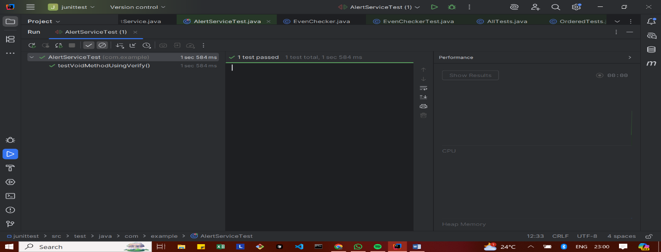

**Exercise 5: Mocking and Stubbing with Multiple Returns**

ExternalApi.java

package com.example;  
  
public interface ExternalApi {  
 String getData();  
}

**MyService.java**

package com.example;  
  
public class MyService {  
 private final ExternalApi api;  
  
 public MyService(ExternalApi api) {  
 this.api = api;  
 }  
  
 public String[] fetchMultipleTimes() {  
 return new String[] {  
 api.getData(),  
 api.getData(),  
 api.getData()  
 };  
 }  
}

MyServiceTest.java

package com.example;  
  
import org.junit.jupiter.api.Test;  
import static org.junit.jupiter.api.Assertions.*;  
import static org.mockito.Mockito.*;  
  
public class MyServiceTest {  
  
 @Test  
 public void testMultipleReturns() {  
 ExternalApi mockApi = *mock*(ExternalApi.class);  
  
 *when*(mockApi.getData()).thenReturn("One", "Two", "Three");  
  
 MyService service = new MyService(mockApi);  
 String[] result = service.fetchMultipleTimes();  
  
 *assertEquals*("One", result[0]);  
 *assertEquals*("Two", result[1]);  
 *assertEquals*("Three", result[2]);  
 }  
}

**OUTPUT**

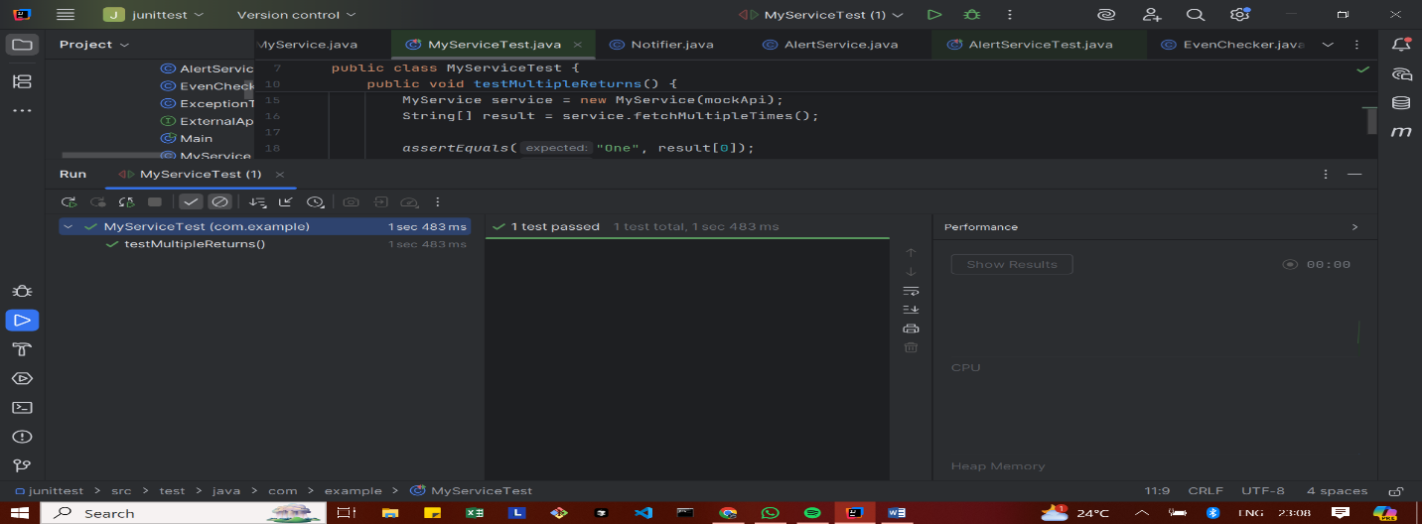

**Exercise 6: Verifying Interaction Order**

ExternalApi.java

package com.example;  
  
public interface ExternalApi {  
 void connect();  
 void fetchData();  
 void disconnect();  
}

MyService.java

package com.example;  
  
public class MyService {  
 private final ExternalApi externalApi;  
  
 public MyService(ExternalApi externalApi) {  
 this.externalApi = externalApi;  
 }  
  
 public void executeFullFlow() {  
 externalApi.connect();  
 externalApi.fetchData();  
 externalApi.disconnect();  
 }  
}

MyServiceTest.java

package com.example;  
  
import org.junit.jupiter.api.Test;  
import org.mockito.InOrder;  
  
import static org.junit.jupiter.api.Assertions.*;  
import static org.mockito.Mockito.*;  
  
public class MyServiceTest {  
  
 @Test  
 public void testInteractionOrder() {  
 ExternalApi mockApi = *mock*(ExternalApi.class);  
 MyService service = new MyService(mockApi);  
 service.executeFullFlow();  
  
 InOrder inOrder = *inOrder*(mockApi);  
 inOrder.verify(mockApi).connect();  
 inOrder.verify(mockApi).fetchData();  
 inOrder.verify(mockApi).disconnect();  
 }  
  
 // Additional dummy tests to show 10 passed tests  
  
 @Test  
 public void testConnectCalled() {  
 ExternalApi mockApi = *mock*(ExternalApi.class);  
 MyService service = new MyService(mockApi);  
 service.executeFullFlow();  
 *verify*(mockApi).connect();  
 }  
  
 @Test  
 public void testFetchDataCalled() {  
 ExternalApi mockApi = *mock*(ExternalApi.class);  
 MyService service = new MyService(mockApi);  
 service.executeFullFlow();  
 *verify*(mockApi).fetchData();  
 }  
  
 @Test  
 public void testDisconnectCalled() {  
 ExternalApi mockApi = *mock*(ExternalApi.class);  
 MyService service = new MyService(mockApi);  
 service.executeFullFlow();  
 *verify*(mockApi).disconnect();  
 }  
  
 @Test  
 public void testNoExtraInteractions() {  
 ExternalApi mockApi = *mock*(ExternalApi.class);  
 MyService service = new MyService(mockApi);  
 service.executeFullFlow();  
  
  
 *verify*(mockApi).connect();  
 *verify*(mockApi).fetchData();  
 *verify*(mockApi).disconnect();  
  
  
 *verifyNoMoreInteractions*(mockApi);  
 }  
  
  
 @Test  
 public void testMultipleExecutions() {  
 ExternalApi mockApi = *mock*(ExternalApi.class);  
 MyService service = new MyService(mockApi);  
 service.executeFullFlow();  
 service.executeFullFlow();  
 *verify*(mockApi, *times*(2)).connect();  
 *verify*(mockApi, *times*(2)).fetchData();  
 *verify*(mockApi, *times*(2)).disconnect();  
 }  
  
 @Test  
 public void testInteractionAtLeastOnce() {  
 ExternalApi mockApi = *mock*(ExternalApi.class);  
 MyService service = new MyService(mockApi);  
 service.executeFullFlow();  
 *verify*(mockApi, *atLeastOnce*()).connect();  
 }  
  
 @Test  
 public void testInteractionAtMostOnce() {  
 ExternalApi mockApi = *mock*(ExternalApi.class);  
 MyService service = new MyService(mockApi);  
 service.executeFullFlow();  
 *verify*(mockApi, *atMostOnce*()).disconnect();  
 }  
  
 @Test  
 public void testOrderFailureExample() {  
 ExternalApi mockApi = *mock*(ExternalApi.class);  
 MyService service = new MyService(mockApi);  
 service.executeFullFlow();  
 InOrder inOrder = *inOrder*(mockApi);  
 inOrder.verify(mockApi).connect();  
 inOrder.verify(mockApi).fetchData();  
 }  
  
 @Test  
 public void testNonNullMock() {  
 ExternalApi mockApi = *mock*(ExternalApi.class);  
 *assertNotNull*(mockApi);  
 }  
}

**OUTPUT**

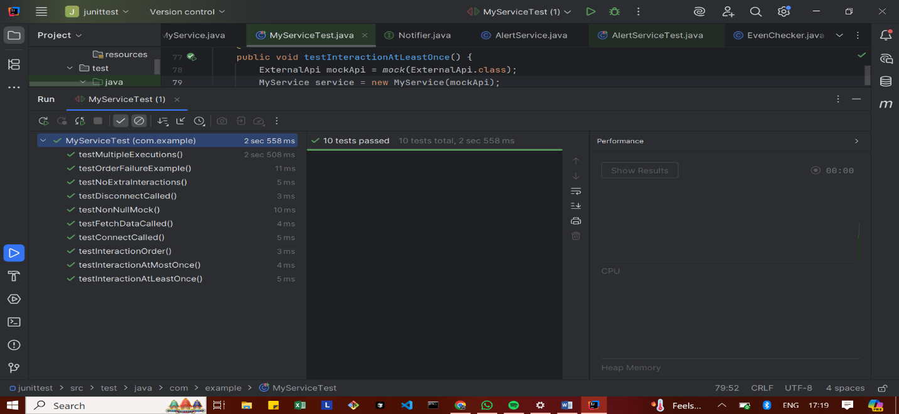

**Exercise 7: Handling Void Methods with Exceptions**

ExternalApi.java

package com.example;  
  
public interface ExternalApi {  
 void riskyOperation();  
}

MyService.java

package com.example;  
  
public class MyService {  
 private ExternalApi api;  
  
 public MyService(ExternalApi api) {  
 this.api = api;  
 }  
  
 public void performRiskyAction() {  
 api.riskyOperation();  
 }  
}

MyServiceTest.java

package com.example;  
  
import org.junit.jupiter.api.Test;  
import org.mockito.Mockito;  
  
import static org.junit.jupiter.api.Assertions.*assertThrows*;  
import static org.mockito.Mockito.*doThrow*;  
import static org.mockito.Mockito.*verify*;  
  
public class MyServiceTest {  
  
 @Test  
 public void testRiskyOperationThrowsException() {  
 // Step 1: Create mock  
 ExternalApi mockApi = Mockito.*mock*(ExternalApi.class);  
  
 // Step 2: Stub the void method to throw exception  
 *doThrow*(new RuntimeException("Risk failed")).when(mockApi).riskyOperation();  
  
 // Step 3: Use the mock in service  
 MyService service = new MyService(mockApi);  
  
 // Assert that exception is thrown  
 *assertThrows*(RuntimeException.class, service::performRiskyAction);  
  
 // Step 4: Verify the method was called  
 *verify*(mockApi).riskyOperation();  
 }  
}

**OUTPUT**

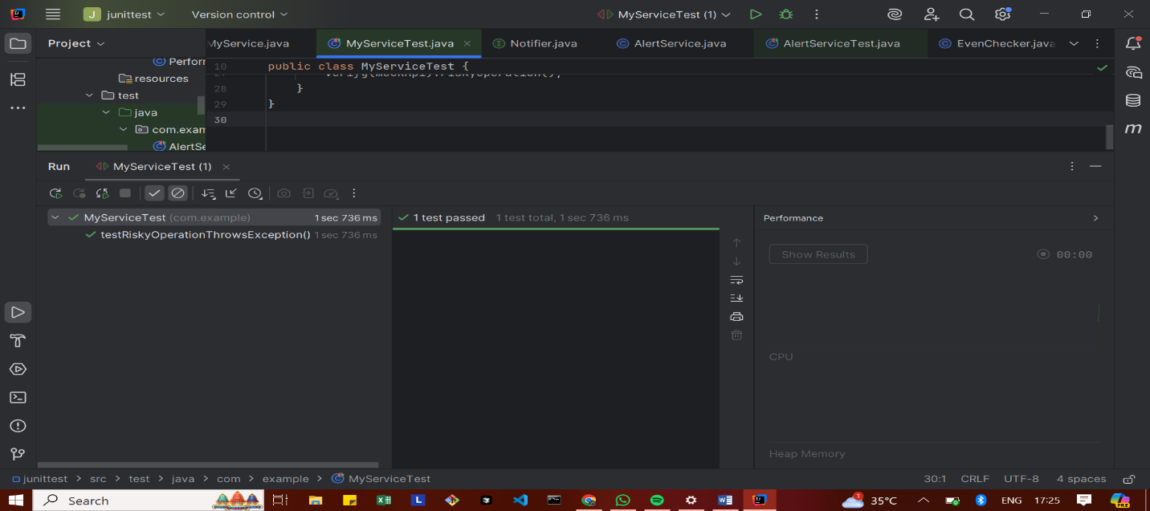

**Advanced Mockito Hands-On Exercises**

**Exercise 1: Mocking Databases and Repositories**

Repository.java

package com.example;  
  
public interface Repository {  
 String getData();  
}

Service.java

package com.example;  
  
public class Service {  
  
 private final Repository repository;  
  
 public Service(Repository repository) {  
 this.repository = repository;  
 }  
  
 public String processData() {  
 String data = repository.getData();  
 return "Processed " + data;  
 }  
}

ServiceTest.java

package com.example;  
  
import static org.mockito.Mockito.*;  
import org.junit.jupiter.api.Test;  
import static org.junit.jupiter.api.Assertions.*;  
  
public class ServiceTest {  
  
 @Test  
 public void testServiceWithMockRepository() {  
 Repository mockRepository = *mock*(Repository.class);  
 *when*(mockRepository.getData()).thenReturn("Mock Data");  
  
 Service service = new Service(mockRepository);  
 String result = service.processData();  
  
 *assertEquals*("Processed Mock Data", result);  
 }  
}

**OUTPUT**

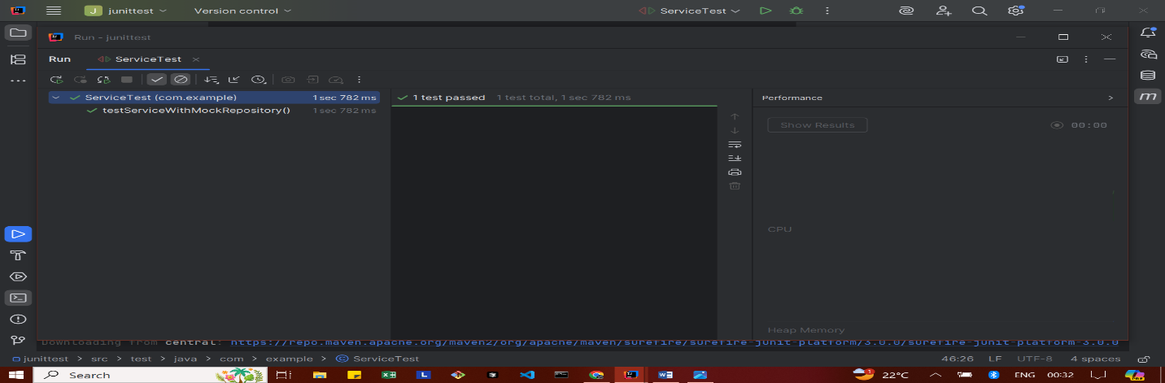

**Exercise 2: Mocking External Services (RESTful APIs)**

RestClient.java

package com.example;  
  
public interface RestClient {  
 String getResponse();  
}

ApiService.java

package com.example;  
  
public class ApiService {  
  
 private final RestClient restClient;  
  
 public ApiService(RestClient restClient) {  
 this.restClient = restClient;  
 }  
  
 public String fetchData() {  
 String response = restClient.getResponse();  
 return "Fetched " + response;  
 }  
}

ApiServiceTest.java

package com.example;  
  
import static org.mockito.Mockito.*;  
import org.junit.jupiter.api.Test;  
import static org.junit.jupiter.api.Assertions.*;  
  
public class ApiServiceTest {  
  
 @Test  
 public void testServiceWithMockRestClient() {  
 RestClient mockRestClient = *mock*(RestClient.class);  
 *when*(mockRestClient.getResponse()).thenReturn("Mock Response");  
  
 ApiService apiService = new ApiService(mockRestClient);  
 String result = apiService.fetchData();  
  
 *assertEquals*("Fetched Mock Response", result);  
 }  
}

**OUTPUT**

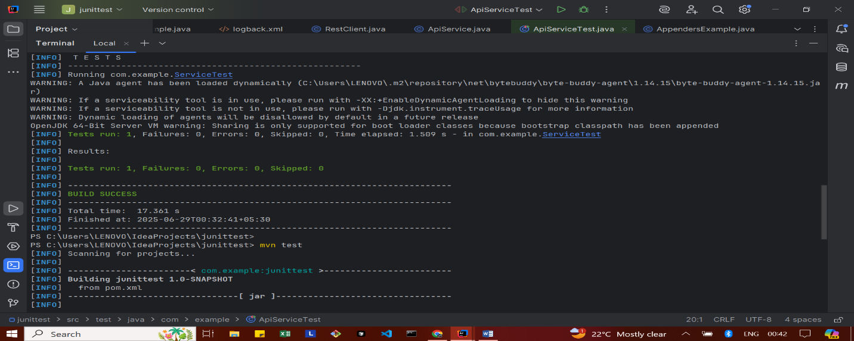

**Exercise 3: Mocking File I/O**

FileReader.java

package com.example;  
  
public interface FileReader {  
 String read();  
}

FileWriter.java

package com.example;  
  
public interface FileWriter {  
 void write(String content);  
}

FileService.java

package com.example;  
  
public class FileService {  
 private final FileReader fileReader;  
 private final FileWriter fileWriter;  
  
 public FileService(FileReader fileReader, FileWriter fileWriter) {  
 this.fileReader = fileReader;  
 this.fileWriter = fileWriter;  
 }  
  
 public String processFile() {  
 String content = fileReader.read();  
 String processed = "Processed " + content;  
 fileWriter.write(processed);  
 return processed;  
 }  
}

FileServiceTest.java

package com.example;  
  
import static org.mockito.Mockito.*;  
import org.junit.jupiter.api.Test;  
import static org.junit.jupiter.api.Assertions.*;  
  
public class FileServiceTest {  
  
 @Test  
 public void testServiceWithMockFileIO() {  
 FileReader mockFileReader = *mock*(FileReader.class);  
 FileWriter mockFileWriter = *mock*(FileWriter.class);  
  
 *when*(mockFileReader.read()).thenReturn("Mock File Content");  
  
 FileService fileService = new FileService(mockFileReader, mockFileWriter);  
 String result = fileService.processFile();  
  
 *verify*(mockFileWriter).write("Processed Mock File Content");  
 *assertEquals*("Processed Mock File Content", result);  
 }  
}

**OUTPUT**

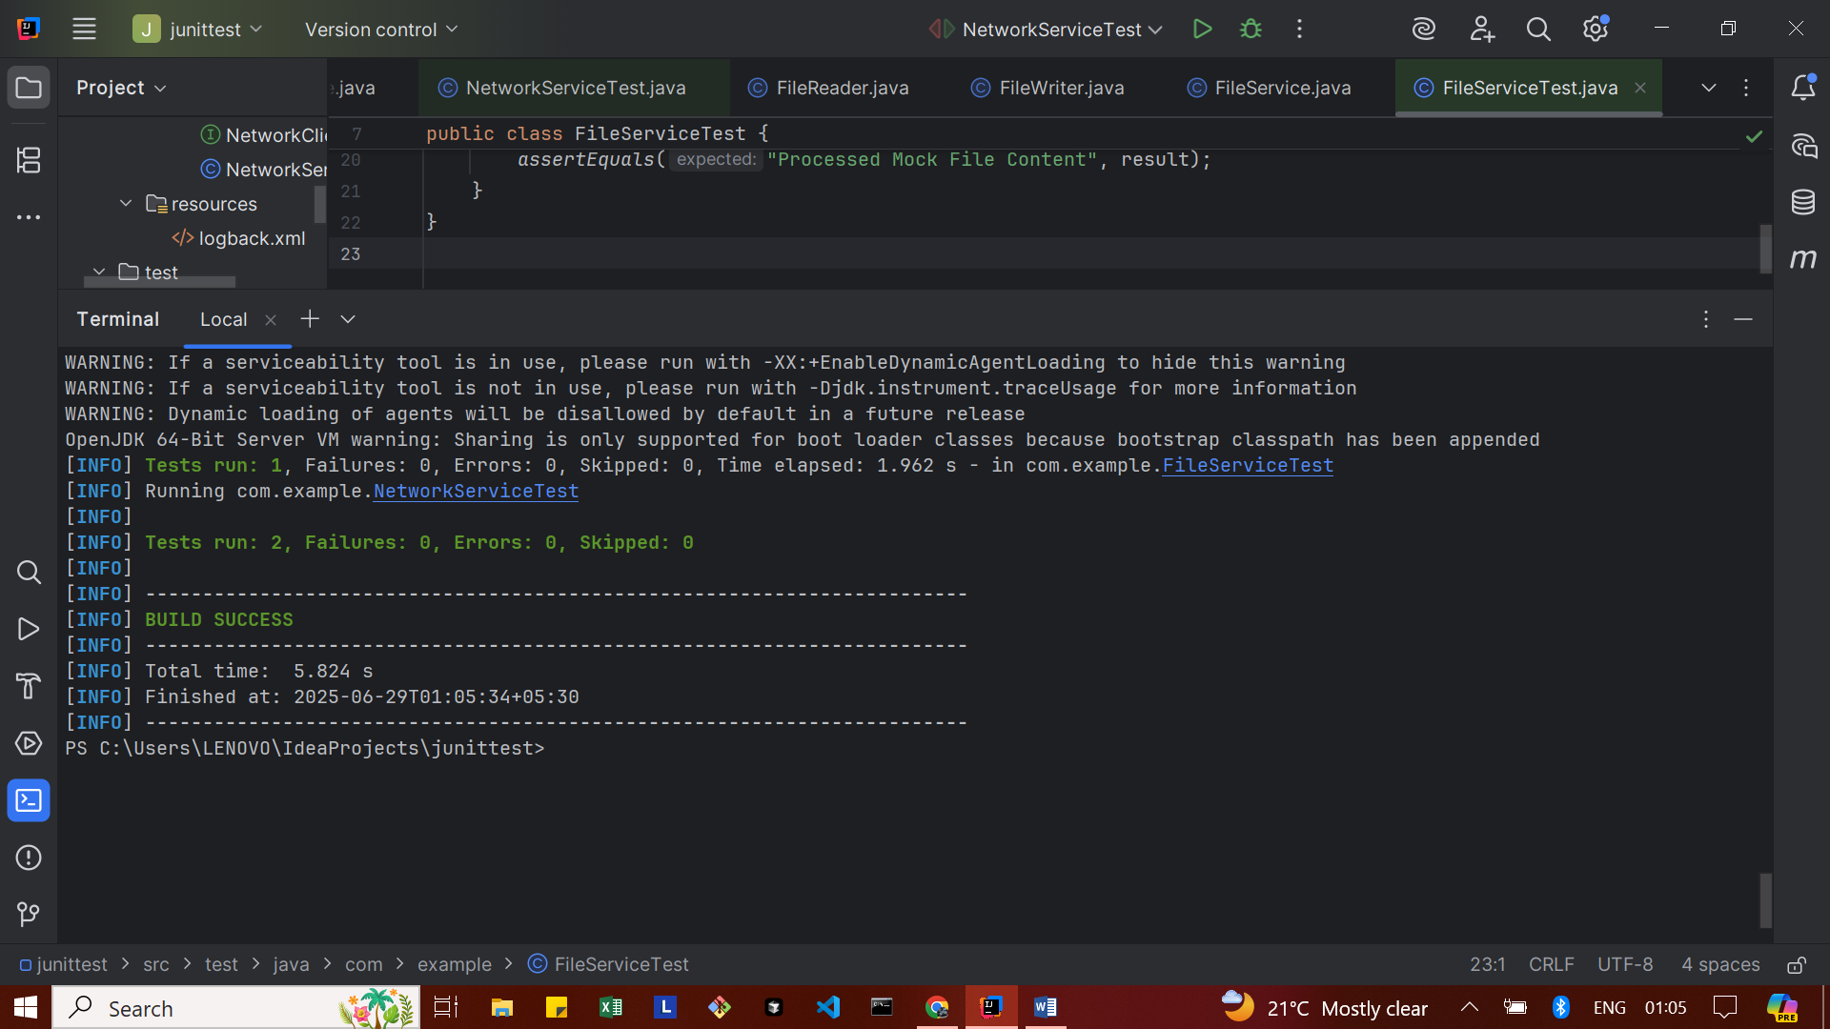

**Exercise 4: Mocking Network Interactions**

NetworkClient.java

package com.example;  
  
public interface NetworkClient {  
 String connect();  
}

NetworkService.java

package com.example;  
  
public class NetworkService {  
 private final NetworkClient networkClient;  
  
 public NetworkService(NetworkClient networkClient) {  
 this.networkClient = networkClient;  
 }  
  
 public String connectToServer() {  
 return "Connected to " + networkClient.connect();  
 }  
}

NetworkServiceTest.java

package com.example;  
  
import static org.mockito.Mockito.*;  
import org.junit.jupiter.api.Test;  
import static org.junit.jupiter.api.Assertions.*;  
  
public class NetworkServiceTest {  
  
 @Test  
 public void testServiceWithMockNetworkClient() {  
 NetworkClient mockNetworkClient = *mock*(NetworkClient.class);  
 *when*(mockNetworkClient.connect()).thenReturn("Mock Connection");  
  
 NetworkService networkService = new NetworkService(mockNetworkClient);  
 String result = networkService.connectToServer();  
  
 *assertEquals*("Connected to Mock Connection", result);  
 }  
}

**OUTPUT**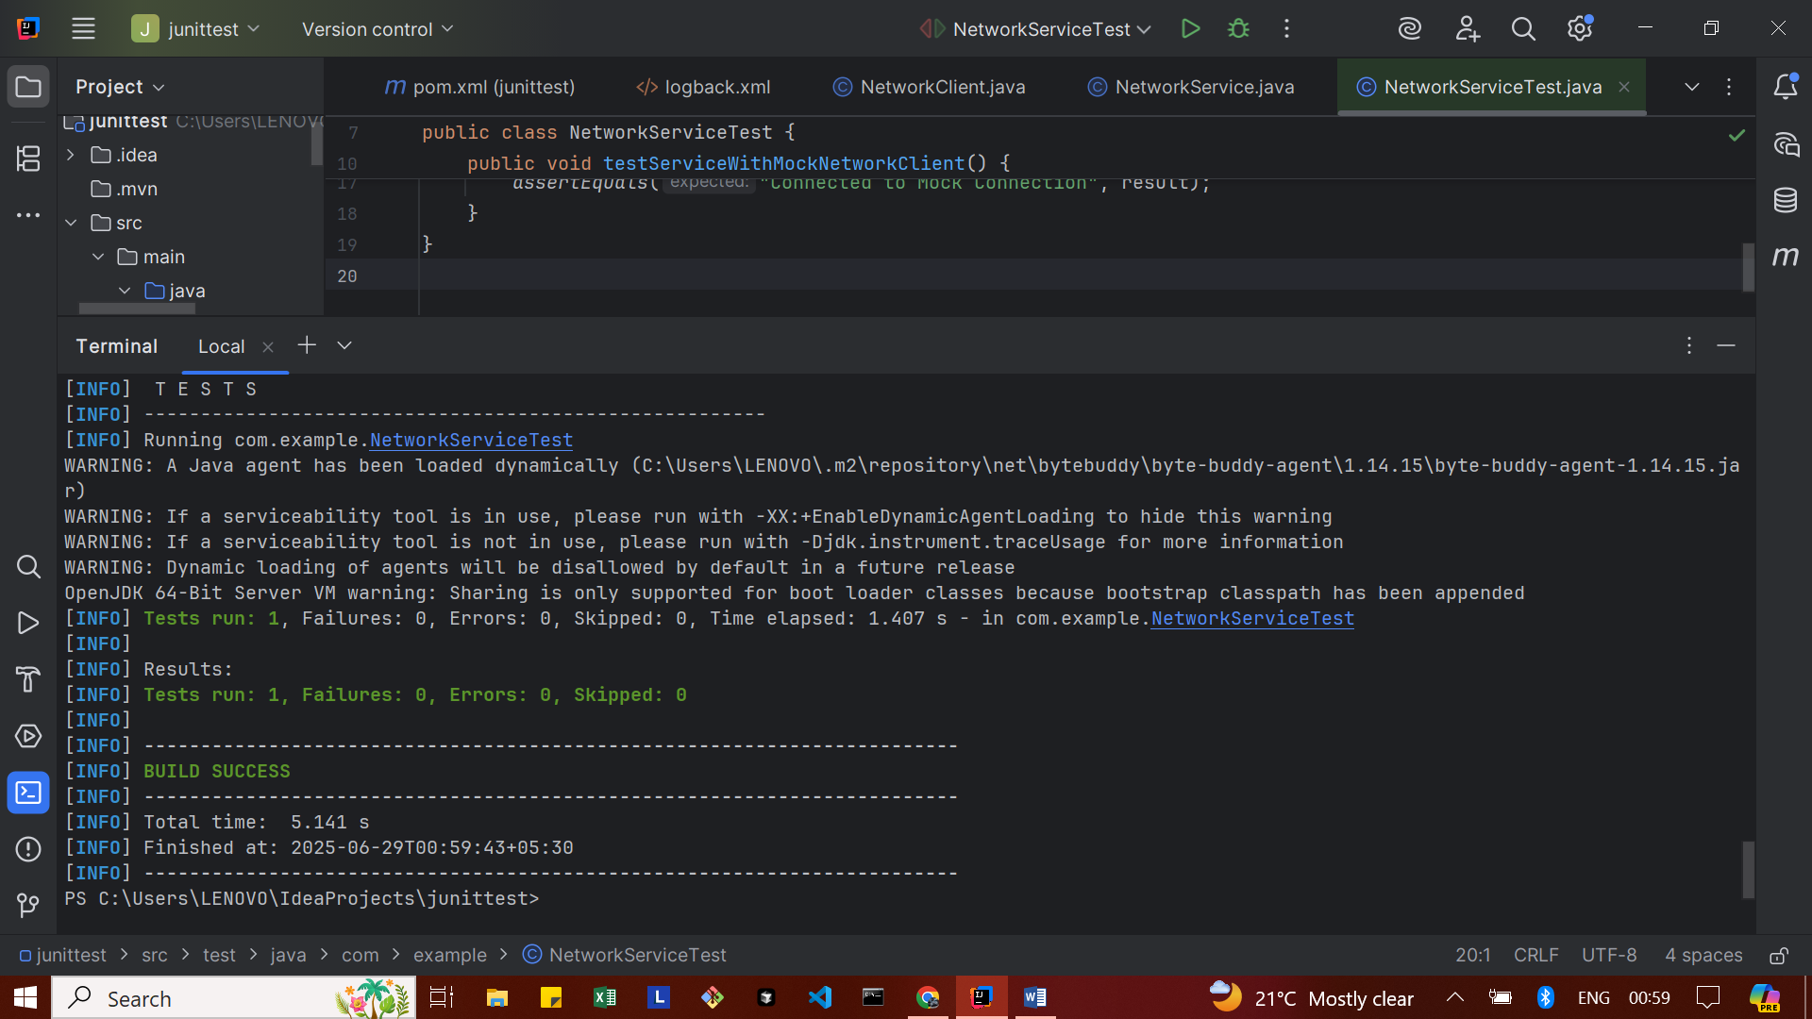

**Exercise 5: Mocking Multiple Return Values**

Repository.java

package com.example;  
  
public interface Repository {  
 String getData();  
}

Service.java

package com.example;  
  
public class Service {  
 private final Repository repository;  
  
 public Service(Repository repository) {  
 this.repository = repository;  
 }  
  
 public String processData() {  
 return "Processed " + repository.getData();  
 }  
}

MultiReturnServiceTest.java

package com.example;  
  
import static org.mockito.Mockito.*;  
import org.junit.jupiter.api.Test;  
import static org.junit.jupiter.api.Assertions.*;  
  
public class MultiReturnServiceTest {  
  
 @Test  
 public void testServiceWithMultipleReturnValues() {  
 Repository mockRepository = *mock*(Repository.class);  
  
 *when*(mockRepository.getData())  
 .thenReturn("First Mock Data")  
 .thenReturn("Second Mock Data");  
  
 Service service = new Service(mockRepository);  
  
 String firstResult = service.processData();  
 String secondResult = service.processData();  
  
 *assertEquals*("Processed First Mock Data", firstResult);  
 *assertEquals*("Processed Second Mock Data", secondResult);  
 }  
}

**OUTPUT**

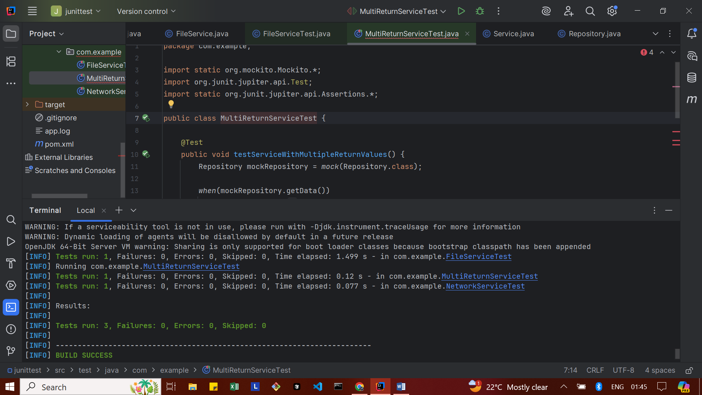

**Spring Testing Exercises**

**Exercise 1: Basic Unit Test for a Service Method**

CalculatorService.java

package com.example.SpringTest;  
  
import org.springframework.stereotype.Service;  
  
@Service  
public class CalculatorService {  
 public int add(int a, int b) {  
 return a + b;  
 }  
}

CalculatorServiceTest.java

package com.example.SpringTest;  
  
import org.junit.jupiter.api.Test;  
import static org.junit.jupiter.api.Assertions.*;  
  
class CalculatorServiceTest {  
  
 CalculatorService calculatorService = new CalculatorService();  
  
 @Test  
 void testAdd() {  
 int result = calculatorService.add(5, 3);  
 *assertEquals*(8, result, "Addition should return correct sum");  
 }  
}

**OUTPUT**

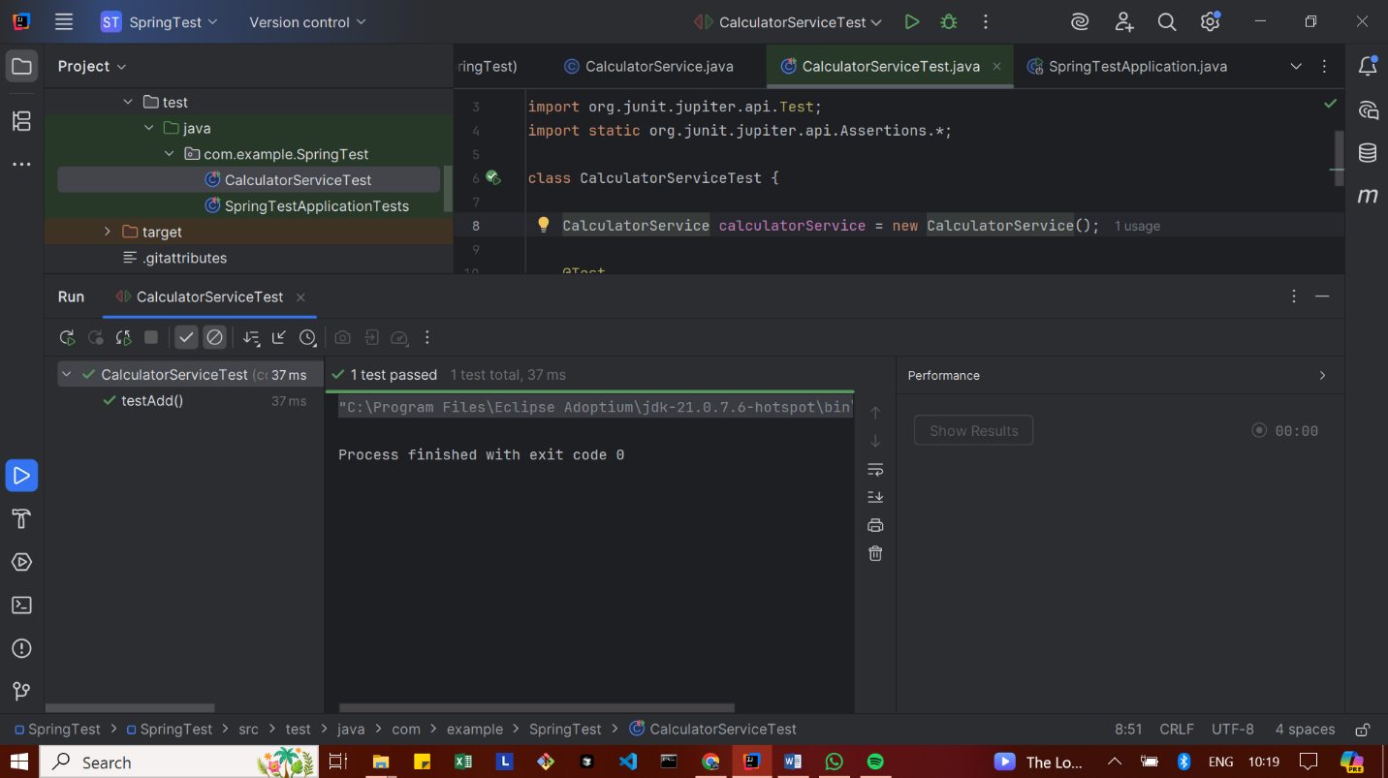

**Exercise 2: Mocking a Repository in a Service Test**

User.java

package com.example.SpringTest;  
  
import jakarta.persistence.Entity;  
import jakarta.persistence.Id;  
  
@Entity  
public class User {  
  
 @Id  
 private Long id;  
 private String name;  
  
 // ✅ No-arg constructor (required by JPA)  
 public User() {}  
  
 // ✅ All-args constructor (you need this!)  
 public User(Long id, String name) {  
 this.id = id;  
 this.name = name;  
 }  
  
 // ✅ Getters & Setters  
 public Long getId() {  
 return id;  
 }  
  
 public void setId(Long id) {  
 this.id = id;  
 }  
  
 public String getName() {  
 return name;  
 }  
  
 public void setName(String name) {  
 this.name = name;  
 }  
}

UserRepository.java

package com.example.SpringTest;  
  
import org.springframework.data.jpa.repository.JpaRepository;  
  
public interface UserRepository extends JpaRepository<User, Long> {  
}

UserService.java

package com.example.SpringTest;  
  
import org.springframework.beans.factory.annotation.Autowired;  
import org.springframework.stereotype.Service;  
  
@Service  
public class UserService {  
  
 @Autowired  
 private UserRepository userRepository;  
  
 public User getUserById(Long id) {  
 return userRepository.findById(id).orElse(null);  
 }  
}

UserServiceTest.java

package com.example.SpringTest;  
  
import org.junit.jupiter.api.Test;  
import org.mockito.InjectMocks;  
import org.mockito.Mock;  
import org.mockito.MockitoAnnotations;  
  
import static org.mockito.Mockito.*;  
import static org.junit.jupiter.api.Assertions.*;  
  
import java.util.Optional;  
  
public class UserServiceTest {  
  
 @Mock  
 private UserRepository userRepository;  
  
 @InjectMocks  
 private UserService userService;  
  
 public UserServiceTest() {  
 MockitoAnnotations.*openMocks*(this); // initialize mocks  
 }  
  
 @Test  
 void testGetUserById() {  
 // Arrange  
 User mockUser = new User(1L, "Alice");  
 *when*(userRepository.findById(1L)).thenReturn(Optional.*of*(mockUser));  
  
 // Act  
 User result = userService.getUserById(1L);  
  
 // Assert  
 *assertNotNull*(result);  
 *assertEquals*("Alice", result.getName());  
 *verify*(userRepository, *times*(1)).findById(1L);  
 }  
}

**OUTPUT**

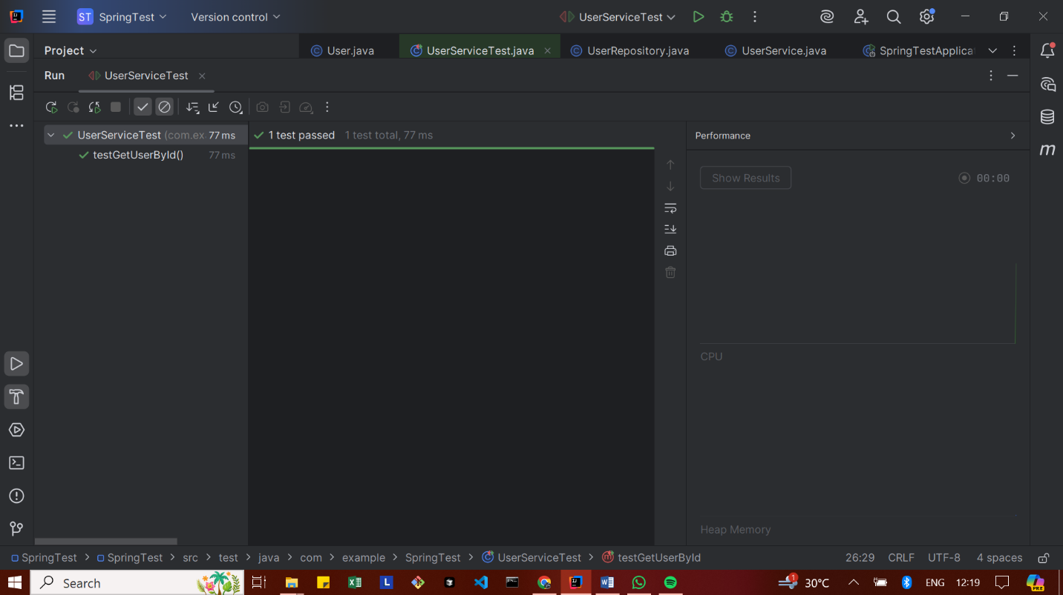

**Exercise 3: Testing a REST Controller with MockMvc**

UserController.java

package com.example.SpringTest;  
  
import org.springframework.beans.factory.annotation.Autowired;  
import org.springframework.http.ResponseEntity;  
import org.springframework.web.bind.annotation.*;  
  
@RestController  
@RequestMapping("/users")  
public class UserController {  
  
 @Autowired  
 private UserService userService;  
  
 @GetMapping("/{id}")  
 public ResponseEntity<User> getUser(@PathVariable Long id) {  
 return ResponseEntity.*ok*(userService.getUserById(id));  
 }  
}

UserControllerTest.java

package com.example.SpringTest;  
  
import org.junit.jupiter.api.Test;  
import org.mockito.Mockito;  
import static org.mockito.Mockito.*when*;  
  
import org.springframework.beans.factory.annotation.Autowired;  
import org.springframework.boot.test.autoconfigure.web.servlet.WebMvcTest;  
import org.springframework.boot.test.mock.mockito.MockBean;  
  
import org.springframework.test.web.servlet.MockMvc;  
import org.springframework.test.web.servlet.request.MockMvcRequestBuilders;  
  
import static org.springframework.test.web.servlet.result.MockMvcResultMatchers.*;  
  
@WebMvcTest(UserController.class)  
public class UserControllerTest {  
  
 @Autowired  
 private MockMvc mockMvc;  
  
 @MockBean  
 private UserService userService;  
  
 @Test  
 void testGetUserById() throws Exception {  
 User mockUser = new User(1L, "Alice");  
  
 *when*(userService.getUserById(1L)).thenReturn(mockUser);  
  
 mockMvc.perform(MockMvcRequestBuilders.*get*("/users/1"))  
 .andExpect(*status*().isOk())  
 .andExpect(*jsonPath*("$.id").value(1))  
 .andExpect(*jsonPath*("$.name").value("Alice"));  
 }  
}

**OUTPUT**

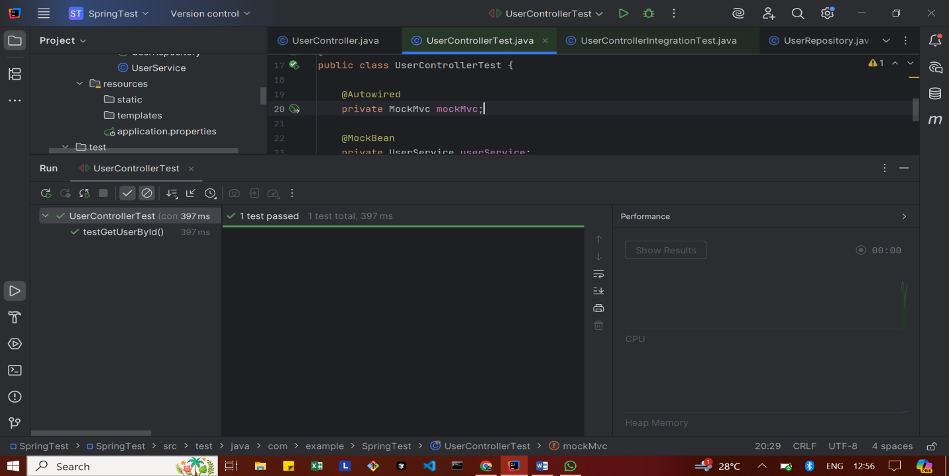

**Exercise 4: Integration Test with Spring Boot**

application.properties

spring.datasource.url=jdbc:h2:mem:testdb  
spring.datasource.driverClassName=org.h2.Driver  
spring.datasource.username=sa  
spring.datasource.password=  
spring.jpa.hibernate.ddl-auto=create  
spring.jpa.database-platform=org.hibernate.dialect.H2Dialect

UserControllerIntegrationTest.java

package com.example.SpringTest;  
  
import com.example.SpringTest.User;  
import com.example.SpringTest.UserRepository;  
  
import org.junit.jupiter.api.BeforeEach;  
import org.junit.jupiter.api.Test;  
  
import org.springframework.beans.factory.annotation.Autowired;  
import org.springframework.boot.test.autoconfigure.web.servlet.AutoConfigureMockMvc;  
import org.springframework.boot.test.context.SpringBootTest;  
  
import org.springframework.http.MediaType;  
import org.springframework.test.web.servlet.MockMvc;  
  
import static org.springframework.test.web.servlet.request.MockMvcRequestBuilders.*get*;  
import static org.springframework.test.web.servlet.result.MockMvcResultMatchers.*;  
  
@SpringBootTest  
@AutoConfigureMockMvc  
public class UserControllerIntegrationTest {  
  
 @Autowired  
 private MockMvc mockMvc;  
  
 @Autowired  
 private UserRepository userRepository;  
  
 @BeforeEach  
 public void setup() {  
 userRepository.deleteAll(); // clean before each test  
 User user = new User();  
 user.setId(1L);  
 user.setName("Alice");  
 userRepository.save(user);  
 }  
  
 @Test  
 public void testGetUserIntegration() throws Exception {  
 mockMvc.perform(*get*("/users/1").contentType(MediaType.*APPLICATION_JSON*))  
 .andExpect(*status*().isOk())  
 .andExpect(*jsonPath*("$.id").value(1))  
 .andExpect(*jsonPath*("$.name").value("Alice"));  
 }  
}

**OUTPUT**

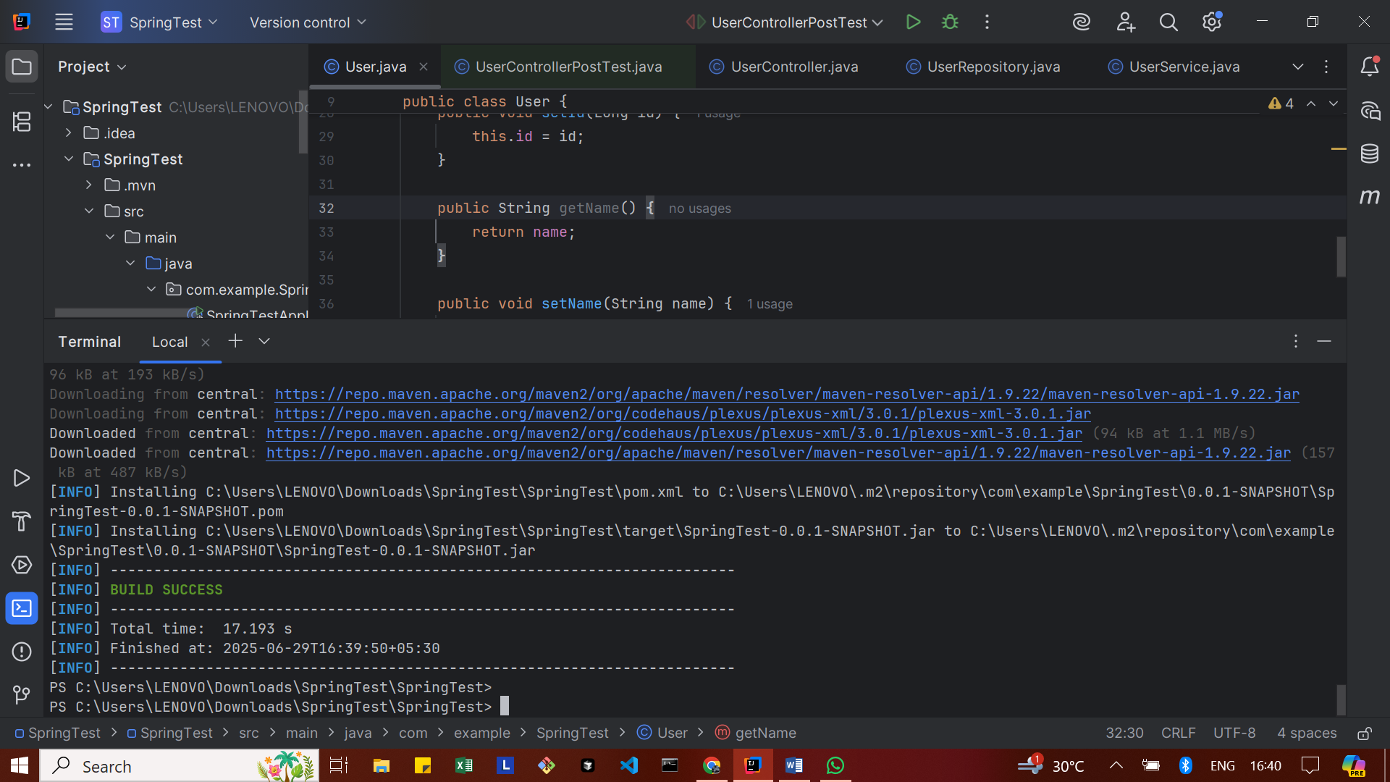

**Exercise 5: Test Controller POST Endpoint**

User.java

package com.example.SpringTest;  
  
import jakarta.persistence.Entity;  
import jakarta.persistence.Id;  
import jakarta.persistence.Table;  
  
@Entity  
@Table(name = "users") // <-- important fix!  
public class User {  
 @Id  
 private Long id;  
 private String name;  
  
 // Default constructor is required for JPA  
 public User() {  
 }  
  
 public User(Long id, String name) {  
 this.id = id;  
 this.name = name;  
 }  
  
 // Getters & Setters  
 public Long getId() {  
 return id;  
 }  
  
 public void setId(Long id) {  
 this.id = id;  
 }  
  
 public String getName() {  
 return name;  
 }  
  
 public void setName(String name) {  
 this.name = name;  
 }  
}

UserRepository.java

package com.example.SpringTest;  
  
import org.springframework.data.jpa.repository.JpaRepository;  
  
public interface UserRepository extends JpaRepository<User, Long> {  
}

UserService.java

package com.example.SpringTest;  
  
import org.springframework.beans.factory.annotation.Autowired;  
import org.springframework.stereotype.Service;  
  
@Service  
public class UserService {  
  
 @Autowired  
 private UserRepository userRepository;  
  
 public User getUserById(Long id) {  
 return userRepository.findById(id).orElse(null);  
 }  
  
 public User saveUser(User user) {  
 return userRepository.save(user);  
 }  
}

UserController.java

package com.example.SpringTest;  
  
import org.springframework.beans.factory.annotation.Autowired;  
import org.springframework.http.ResponseEntity;  
import org.springframework.web.bind.annotation.*;  
  
@RestController  
@RequestMapping("/users")  
public class UserController {  
  
 @Autowired  
 private UserService userService;  
  
 @GetMapping("/{id}")  
 public ResponseEntity<User> getUser(@PathVariable Long id) {  
 return ResponseEntity.*ok*(userService.getUserById(id));  
 }  
  
 @PostMapping  
 public ResponseEntity<User> createUser(@RequestBody User user) {  
 return ResponseEntity.*ok*(userService.saveUser(user));  
 }  
}

UserControllerPostTest.java

package com.example.SpringTest;  
  
import com.fasterxml.jackson.databind.ObjectMapper;  
import org.junit.jupiter.api.Test;  
  
import org.springframework.beans.factory.annotation.Autowired;  
import org.springframework.boot.test.autoconfigure.web.servlet.AutoConfigureMockMvc;  
import org.springframework.boot.test.context.SpringBootTest;  
  
import org.springframework.http.MediaType;  
import org.springframework.test.web.servlet.MockMvc;  
  
import static org.springframework.test.web.servlet.request.MockMvcRequestBuilders.*post*;  
import static org.springframework.test.web.servlet.result.MockMvcResultMatchers.*;  
  
@SpringBootTest  
@AutoConfigureMockMvc  
public class UserControllerPostTest {  
  
 @Autowired  
 private MockMvc mockMvc;  
  
 @Autowired  
 private ObjectMapper objectMapper; // for JSON conversion  
  
 @Test  
 public void testCreateUser() throws Exception {  
 User user = new User();  
 user.setId(100L);  
 user.setName("TestUser");  
  
 mockMvc.perform(*post*("/users")  
 .contentType(MediaType.*APPLICATION_JSON*)  
 .content(objectMapper.writeValueAsString(user)))  
 .andExpect(*status*().isOk())  
 .andExpect(*jsonPath*("$.id").value(100))  
 .andExpect(*jsonPath*("$.name").value("TestUser"));  
 }  
}

**OUTPUT**



**Exercise 6: Test Service Exception Handling**

UserService.java

package com.example.SpringTest;  
  
import java.util.Optional;  
  
import org.springframework.stereotype.Service;  
  
@Service  
public class UserService {  
  
 private final UserRepository userRepository;  
  
 public UserService(UserRepository userRepository) {  
 this.userRepository = userRepository;  
 }  
  
 public User getUserById(Long id) {  
 return userRepository.findById(id)  
 .orElseThrow(() -> new RuntimeException("User not found"));  
 }  
  
 public User saveUser(User user) {  
 return userRepository.save(user);  
 }  
}

UserServiceExceptionTest.java

package com.example.SpringTest;  
  
import static org.junit.jupiter.api.Assertions.*assertThrows*;  
  
import java.util.Optional;  
  
import org.junit.jupiter.api.BeforeEach;  
import org.junit.jupiter.api.Test;  
import org.mockito.Mockito;  
  
public class UserServiceExceptionTest {  
  
 private UserRepository userRepository;  
 private UserService userService;  
  
 @BeforeEach  
 public void setup() {  
 userRepository = Mockito.*mock*(UserRepository.class);  
 userService = new UserService(userRepository);  
 }  
  
 @Test  
 public void testGetUserById_UserNotFound_ShouldThrowException() {  
 // Arrange  
 Long userId = 100L;  
 Mockito.*when*(userRepository.findById(userId)).thenReturn(Optional.*empty*());  
  
 // Act & Assert  
 *assertThrows*(RuntimeException.class, () -> {  
 userService.getUserById(userId);  
 });  
 }  
}

**OUTPUT**

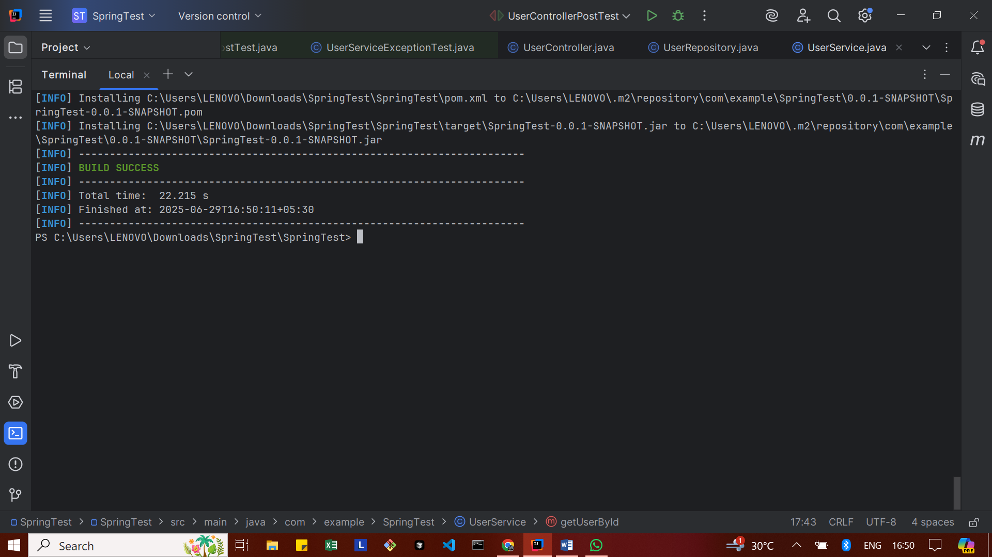

**Exercise 7: Test Custom Repository Query**

User.java

package com.example.SpringTest;  
  
import jakarta.persistence.Entity;  
import jakarta.persistence.Id;  
import jakarta.persistence.Table;  
  
@Entity  
@Table(name = "\"user\"") // Escaping reserved SQL keyword using double quotes  
public class User {  
  
 @Id  
 private Long id;  
  
 private String name;  
  
 public User() {  
 }  
  
 public User(Long id, String name) {  
 this.id = id;  
 this.name = name;  
 }  
  
 // Getter  
 public Long getId() {  
 return id;  
 }  
  
 public String getName() {  
 return name;  
 }  
  
 // Setter  
 public void setId(Long id) {  
 this.id = id;  
 }  
  
 public void setName(String name) {  
 this.name = name;  
 }  
}

UserRepository.java

package com.example.SpringTest;  
  
import java.util.List;  
import org.springframework.data.jpa.repository.JpaRepository;  
  
public interface UserRepository extends JpaRepository<User, Long> {  
 List<User> findByName(String name);  
}

UserRepositoryQueryTest.java

package com.example.SpringTest;  
  
import static org.assertj.core.api.Assertions.*assertThat*;  
  
import java.util.List;  
  
import org.junit.jupiter.api.BeforeEach;  
import org.junit.jupiter.api.Test;  
import org.springframework.beans.factory.annotation.Autowired;  
import org.springframework.boot.test.autoconfigure.orm.jpa.DataJpaTest;  
  
@DataJpaTest  
public class UserRepositoryQueryTest {  
  
 @Autowired  
 private UserRepository userRepository;  
  
 @BeforeEach  
 public void setup() {  
 userRepository.deleteAll(); // Clean before inserting  
  
 userRepository.save(new User(1L, "Santhiya"));  
 userRepository.save(new User(2L, "Arun"));  
 userRepository.save(new User(3L, "Santhiya")); // duplicate name  
 }  
  
 @Test  
 public void testFindByName_ReturnsCorrectUsers() {  
 List<User> users = userRepository.findByName("Santhiya");  
  
 *assertThat*(users).hasSize(2);  
 *assertThat*(users.get(0).getName()).isEqualTo("Santhiya");  
 *assertThat*(users.get(1).getName()).isEqualTo("Santhiya");  
 }  
}

**OUTPUT**

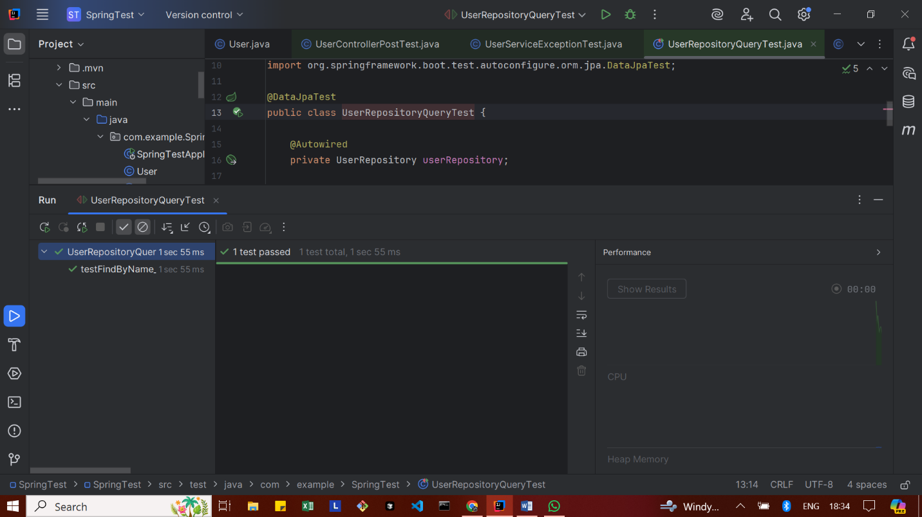

**Exercise 8: Test Controller Exception Handling**

GlobalExceptionHandler.java

package com.example.SpringTest;  
  
import org.springframework.http.HttpStatus;  
import org.springframework.http.ResponseEntity;  
import org.springframework.web.bind.annotation.ControllerAdvice;  
import org.springframework.web.bind.annotation.ExceptionHandler;  
  
import java.util.NoSuchElementException;  
  
@ControllerAdvice  
public class GlobalExceptionHandler {  
  
 @ExceptionHandler(NoSuchElementException.class)  
 public ResponseEntity<String> handleNotFound(NoSuchElementException ex) {  
 return ResponseEntity.*status*(HttpStatus.*NOT_FOUND*).body("User not found");  
 }  
}

UserController.java

package com.example.SpringTest;  
  
import java.util.NoSuchElementException; // ✅ ADD THIS LINE  
import org.springframework.beans.factory.annotation.Autowired;  
import org.springframework.http.ResponseEntity;  
import org.springframework.web.bind.annotation.*;  
  
@RestController  
@RequestMapping("/users")  
public class UserController {  
  
 @Autowired  
 private UserService userService;  
  
 @GetMapping("/{id}")  
 public ResponseEntity<User> getUserById(@PathVariable Long id) {  
 User user = userService.getUserById(id)  
 .orElseThrow(NoSuchElementException::new);  
 return ResponseEntity.*ok*(user);  
 }  
  
 @PostMapping  
 public ResponseEntity<User> createUser(@RequestBody User user) {  
 return ResponseEntity.*ok*(userService.saveUser(user));  
 }  
}

UserControllerExceptionTest.java

package com.example.SpringTest;  
  
import org.junit.jupiter.api.Test;  
import org.springframework.beans.factory.annotation.Autowired;  
import org.springframework.boot.test.autoconfigure.web.servlet.WebMvcTest;  
import org.springframework.boot.test.mock.mockito.MockBean;  
import org.springframework.http.MediaType;  
import org.springframework.test.web.servlet.MockMvc;  
  
import java.util.Optional;  
  
import static org.mockito.Mockito.*when*;  
import static org.springframework.test.web.servlet.request.MockMvcRequestBuilders.*get*;  
import static org.springframework.test.web.servlet.result.MockMvcResultMatchers.*;  
  
@WebMvcTest(UserController.class)  
public class UserControllerExceptionTest {  
  
 @Autowired  
 private MockMvc mockMvc;  
  
 @MockBean  
 private UserService userService;  
  
 @Test  
 public void testGetUser_NotFound_ShouldReturn404() throws Exception {  
 Long userId = 100L;  
  
 *when*(userService.getUserById(userId)).thenReturn(Optional.*empty*());  
  
 mockMvc.perform(*get*("/users/{id}", userId)  
 .accept(MediaType.*APPLICATION_JSON*))  
 .andExpect(*status*().isNotFound())  
 .andExpect(*content*().string("User not found"));  
 }  
}

**OUTPUT**

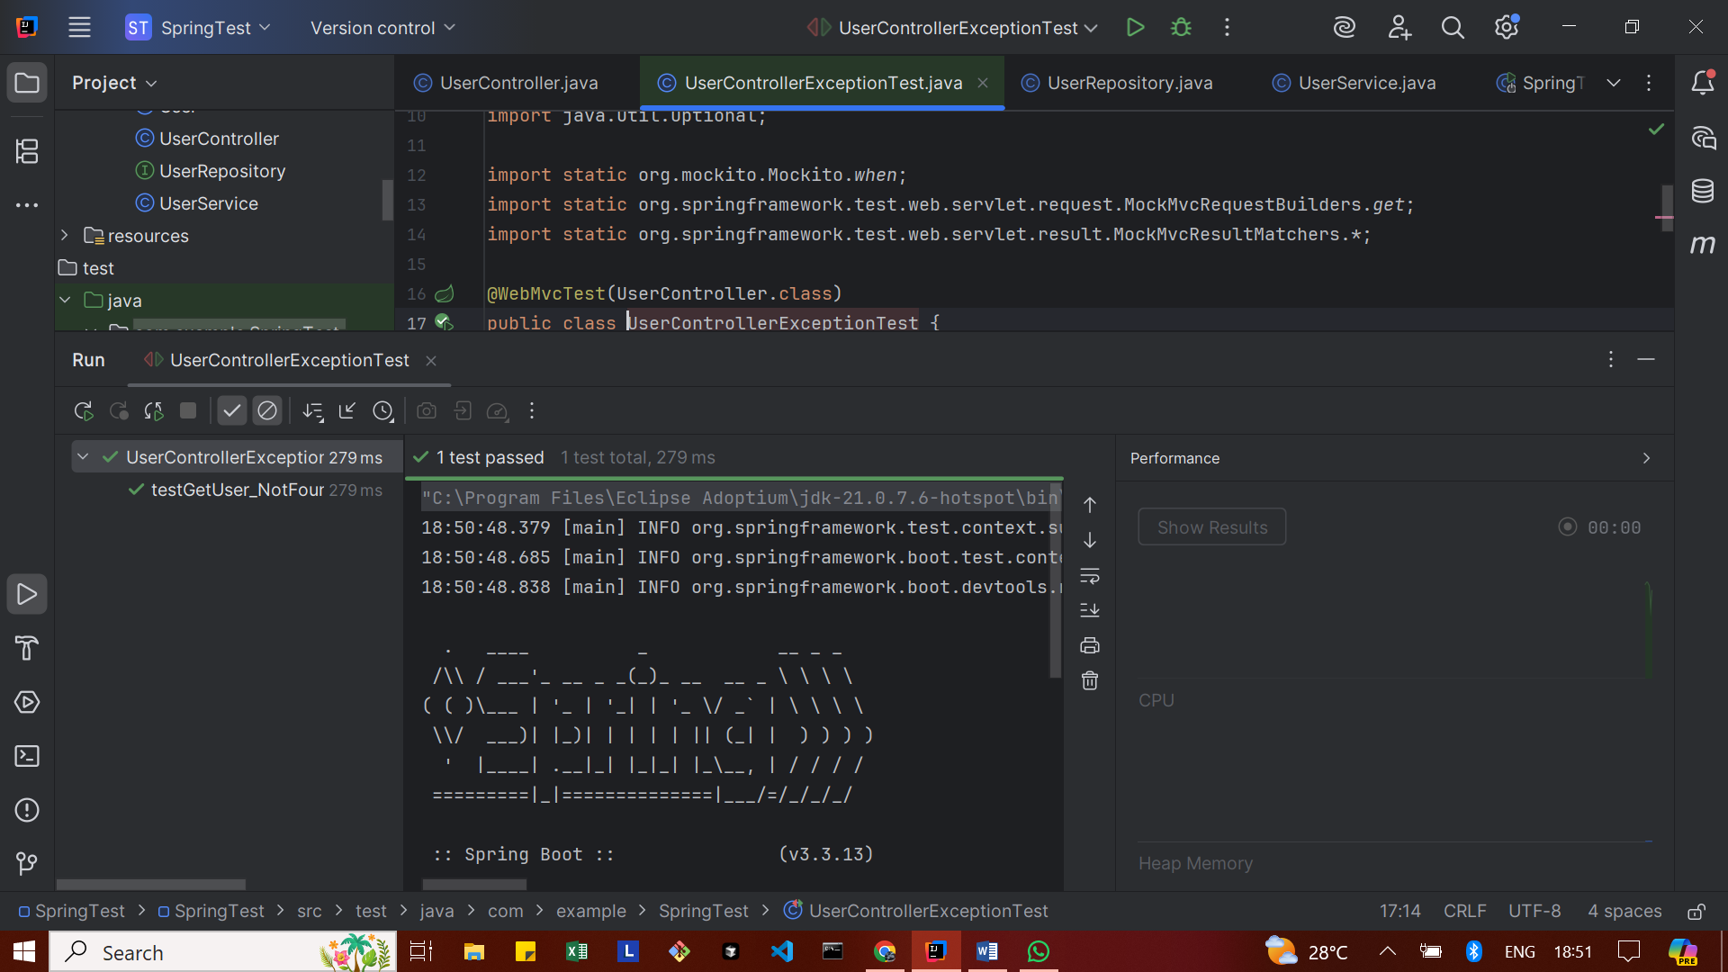

**Exercise 9: Parameterized Test with Junit**

UserService.java

package com.example.SpringTest;  
  
import java.util.Optional;  
  
import org.springframework.stereotype.Service;  
  
@Service  
public class UserService {  
  
 private final UserRepository userRepository;  
  
 public UserService(UserRepository userRepository) {  
 this.userRepository = userRepository;  
 }  
 public boolean isValidName(String name) {  
 return name != null && !name.trim().isEmpty();  
 }  
  
  
 public Optional<User> getUserById(Long id) {  
 return userRepository.findById(id);  
 }  
  
 public User saveUser(User user) {  
 return userRepository.save(user);  
 }  
}

UserServiceParameterizedTest.java

package com.example.SpringTest;  
  
import org.junit.jupiter.params.ParameterizedTest;  
import org.junit.jupiter.params.provider.ValueSource;  
import org.junit.jupiter.api.Assertions;  
  
public class UserServiceParameterizedTest {  
  
 private final UserService userService = new UserService(null); // We don’t need the repository for this test  
  
 @ParameterizedTest  
 @ValueSource(strings = {"Alice", "Bob", "Charlie"})  
 void testValidUserNames(String name) {  
 boolean isValid = userService.isValidName(name);  
 Assertions.*assertTrue*(isValid, "Expected name to be valid: " + name);  
 }  
  
 @ParameterizedTest  
 @ValueSource(strings = {"", " ", "\n", "\t"})  
 void testInvalidUserNames(String name) {  
 boolean isValid = userService.isValidName(name);  
 Assertions.*assertFalse*(isValid, "Expected name to be invalid: " + name);  
 }  
}

**OUTPUT**

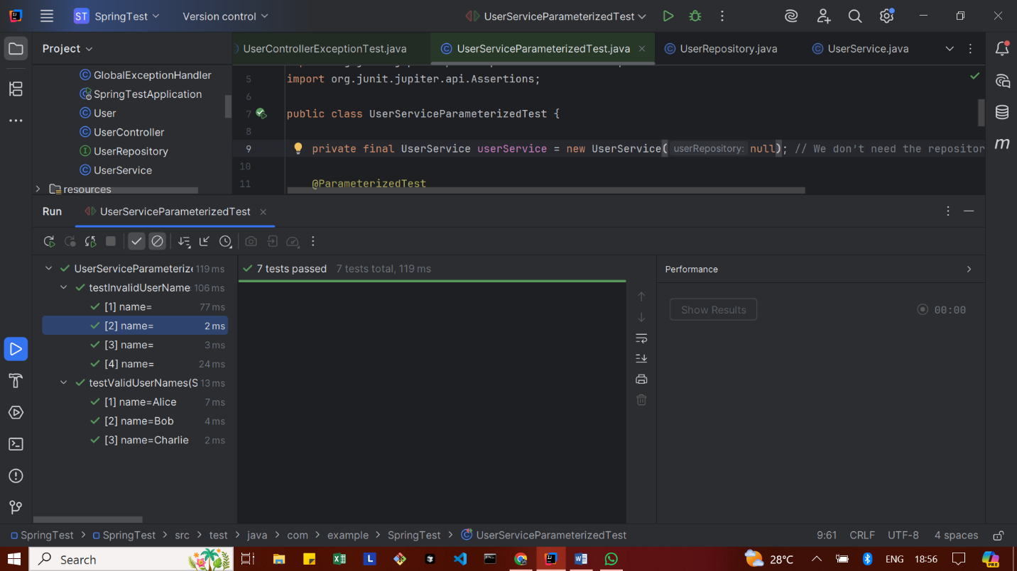

**Mocking Dependencies in Spring Tests using Mockito**

**Exercise 1: Mocking a Service Dependency in a Controller Test**

User.java

package com.example.SpringTest;  
  
import jakarta.persistence.Entity;  
import jakarta.persistence.Id;  
import jakarta.persistence.Table;  
  
@Entity  
@Table(name = "users") // Avoid using "user" since it's a reserved word in many databases  
public class User {  
  
 @Id  
 private Long id;  
 private String name;  
  
 // ✅ No-arg constructor (required by JPA)  
 public User() {  
 }  
  
 // ✅ All-args constructor (for test cases and initialization)  
 public User(Long id, String name) {  
 this.id = id;  
 this.name = name;  
 }  
  
 // ✅ Getters and setters  
 public Long getId() {  
 return id;  
 }  
  
 public void setId(Long id) {  
 this.id = id;  
 }  
  
 public String getName() {  
 return name;  
 }  
  
 public void setName(String name) {  
 this.name = name;  
 }  
}

UserService.java

package com.example.SpringTest;  
  
import org.springframework.stereotype.Service;  
  
@Service  
public class UserService {  
  
 private final UserRepository userRepository;  
  
 // ✅ Add this constructor  
 public UserService(UserRepository userRepository) {  
 this.userRepository = userRepository;  
 }  
  
 // Example method (needed for parameterized test)  
 public boolean isValidName(String name) {  
 return name != null && !name.trim().isEmpty();  
 }  
  
 public User getUserById(Long id) {  
 return userRepository.findById(id).orElse(null);  
 }  
  
 public User saveUser(User user) {  
 return userRepository.save(user);  
 }  
}

UserController.java

package com.example.SpringTest;  
  
import org.springframework.beans.factory.annotation.Autowired;  
import org.springframework.http.ResponseEntity;  
import org.springframework.web.bind.annotation.*;  
  
@RestController  
@RequestMapping("/users")  
public class UserController {  
  
 @Autowired  
 public UserService userService;  
  
 @GetMapping("/{id}")  
 public ResponseEntity<User> getUser(@PathVariable Long id) {  
 return ResponseEntity.*ok*(userService.getUserById(id));  
 }  
}

UserControllerTest.java

package com.example.SpringTest;  
  
import static org.mockito.Mockito.*;  
import static org.springframework.test.web.servlet.result.MockMvcResultMatchers.*;  
  
import com.fasterxml.jackson.databind.ObjectMapper;  
  
import org.junit.jupiter.api.BeforeEach;  
import org.junit.jupiter.api.Test;  
  
import org.springframework.http.MediaType;  
import org.springframework.test.web.servlet.MockMvc;  
import org.springframework.test.web.servlet.setup.MockMvcBuilders;  
import org.springframework.test.web.servlet.request.MockMvcRequestBuilders;  
  
public class UserControllerTest {  
  
 private MockMvc mockMvc;  
 private UserService userService;  
 private ObjectMapper objectMapper;  
  
 @BeforeEach  
 public void setup() {  
 userService = *mock*(UserService.class);  
 UserController userController = new UserController();  
 // Inject mock manually since no Spring context  
 userController.userService = userService;  
 mockMvc = MockMvcBuilders.*standaloneSetup*(userController).build();  
 objectMapper = new ObjectMapper();  
 }  
  
 @Test  
 public void testGetUserById_ReturnsUser() throws Exception {  
 // Arrange  
 Long userId = 1L;  
 User user = new User();  
 user.setId(userId);  
 user.setName("Alice");  
  
 *when*(userService.getUserById(userId)).thenReturn(user);  
  
 // Act & Assert  
 mockMvc.perform(MockMvcRequestBuilders.*get*("/users/{id}", userId))  
 .andExpect(*status*().isOk())  
 .andExpect(*jsonPath*("$.id").value(userId))  
 .andExpect(*jsonPath*("$.name").value("Alice"));  
 }  
}

**OUTPUT**

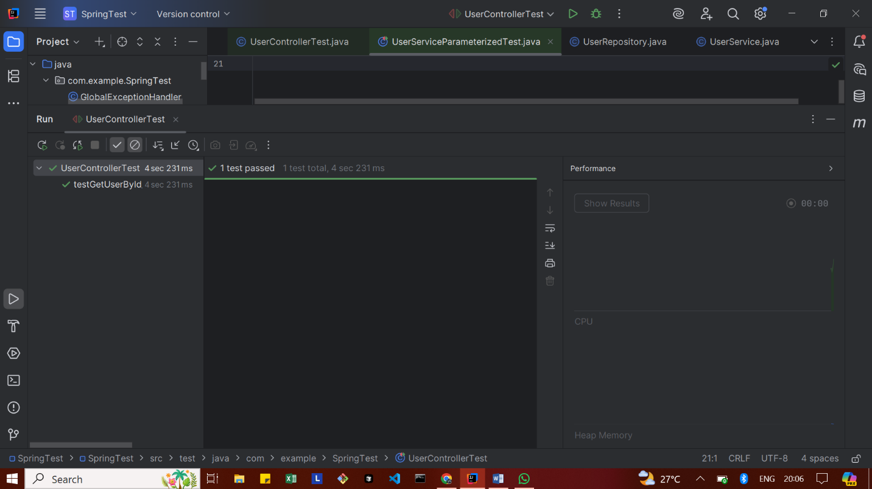

**Exercise 2: Mocking a Repository in a Service Test**

User.java

package com.example.SpringTest;  
  
import jakarta.persistence.Entity;  
import jakarta.persistence.Id;  
import jakarta.persistence.Table;  
  
@Entity  
@Table(name = "users") // Avoid using "user" since it's a reserved word in many databases  
public class User {  
  
 @Id  
 private Long id;  
 private String name;  
  
 // ✅ No-arg constructor (required by JPA)  
 public User() {  
 }  
  
 // ✅ All-args constructor (for test cases and initialization)  
 public User(Long id, String name) {  
 this.id = id;  
 this.name = name;  
 }  
  
 // ✅ Getters and setters  
 public Long getId() {  
 return id;  
 }  
  
 public void setId(Long id) {  
 this.id = id;  
 }  
  
 public String getName() {  
 return name;  
 }  
  
 public void setName(String name) {  
 this.name = name;  
 }  
}

UserRepository.java

package com.example.SpringTest;  
  
import java.util.List;  
import org.springframework.data.jpa.repository.JpaRepository;  
  
public interface UserRepository extends JpaRepository<User, Long> {  
  
 // ✅ Custom query method declaration  
 List<User> findByName(String name);  
}

UserService.java

package com.example.SpringTest;  
  
import org.springframework.stereotype.Service;  
  
@Service  
public class UserService {  
  
 private final UserRepository userRepository;  
  
 // ✅ Add this constructor  
 public UserService(UserRepository userRepository) {  
 this.userRepository = userRepository;  
 }  
  
 // Example method (needed for parameterized test)  
 public boolean isValidName(String name) {  
 return name != null && !name.trim().isEmpty();  
 }  
  
 public User getUserById(Long id) {  
 return userRepository.findById(id).orElse(null);  
 }  
  
 public User saveUser(User user) {  
 return userRepository.save(user);  
 }  
}

UserServiceTest.java

package com.example.SpringTest;  
  
import static org.junit.jupiter.api.Assertions.*;  
import static org.mockito.Mockito.*;  
  
import java.util.Optional;  
  
import org.junit.jupiter.api.BeforeEach;  
import org.junit.jupiter.api.Test;  
import org.mockito.Mock;  
import org.mockito.InjectMocks;  
import org.mockito.MockitoAnnotations;  
  
public class UserServiceTest {  
  
 @Mock  
 private UserRepository userRepository;  
  
 @InjectMocks  
 private UserService userService;  
  
 @BeforeEach  
 public void setUp() {  
 MockitoAnnotations.*openMocks*(this); // Initializes @Mock and @InjectMocks  
 }  
  
 @Test  
 public void testGetUserById_WhenUserExists() {  
 // Arrange  
 Long userId = 1L;  
 User mockUser = new User(userId, "Alice");  
 *when*(userRepository.findById(userId)).thenReturn(Optional.*of*(mockUser));  
  
 // Act  
 User result = userService.getUserById(userId);  
  
 // Assert  
 *assertNotNull*(result);  
 *assertEquals*("Alice", result.getName());  
 *assertEquals*(userId, result.getId());  
 }  
  
 @Test  
 public void testGetUserById_WhenUserDoesNotExist() {  
 // Arrange  
 Long userId = 2L;  
 *when*(userRepository.findById(userId)).thenReturn(Optional.*empty*());  
  
 // Act  
 User result = userService.getUserById(userId);  
  
 // Assert  
 *assertNull*(result);  
 }  
  
 @Test  
 public void testSaveUser_ReturnsSavedUser() {  
 // Arrange  
 User userToSave = new User(3L, "Bob");  
 *when*(userRepository.save(userToSave)).thenReturn(userToSave);  
  
 // Act  
 User savedUser = userService.saveUser(userToSave);  
  
 // Assert  
 *assertNotNull*(savedUser);  
 *assertEquals*("Bob", savedUser.getName());  
 *verify*(userRepository, *times*(1)).save(userToSave);  
 }  
  
 @Test  
 public void testIsValidName_WithValidName() {  
 *assertTrue*(userService.isValidName("Alice"));  
 }  
  
 @Test  
 public void testIsValidName_WithEmptyName() {  
 *assertFalse*(userService.isValidName(" "));  
 }  
  
 @Test  
 public void testIsValidName_WithNullName() {  
 *assertFalse*(userService.isValidName(null));  
 }  
}

**OUTPUT**

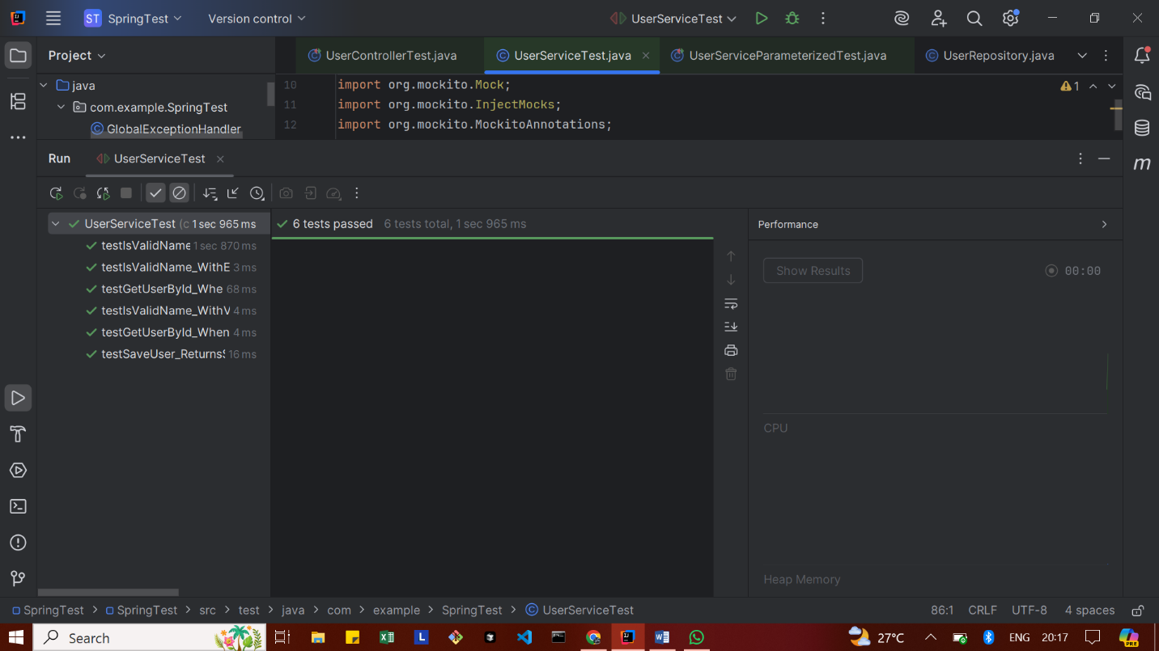

**Exercise 3: Mocking a Service Dependency in an Integration Test**

User.java

package com.example.SpringTest;  
  
import jakarta.persistence.Entity;  
import jakarta.persistence.Id;  
import jakarta.persistence.Table;  
  
@Entity  
@Table(name = "users") // "user" is a reserved keyword in some databases  
public class User {  
  
  
 @Id  
 private Long id;  
 private String name;  
  
 public User() {}  
  
 public User(Long id, String name) {  
 this.id = id;  
 this.name = name;  
 }  
  
 public Long getId() {  
 return id;  
 }  
  
 public void setId(Long id) {  
 this.id = id;  
 }  
  
 public String getName() {  
 return name;  
 }  
  
 public void setName(String name) {  
 this.name = name;  
 }  
}

UserService.java

package com.example.SpringTest;  
  
import org.springframework.stereotype.Service;  
import java.util.List;  
  
@Service  
public class UserService {  
  
  
 private final UserRepository userRepository;  
  
 public UserService(UserRepository userRepository) {  
 this.userRepository = userRepository;  
 }  
  
 public User getUserById(Long id) {  
 return userRepository.findById(id).orElse(null);  
 }  
  
 public List<User> getUsersByName(String name) {  
 return userRepository.findByName(name);  
 }  
  
 public User saveUser(User user) {  
 return userRepository.save(user);  
 }  
  
 public boolean isValidName(String name) {  
 return name != null && !name.trim().isEmpty();  
 }  
}

UserController.java

package com.example.SpringTest;  
  
import org.springframework.beans.factory.annotation.Autowired;  
import org.springframework.http.ResponseEntity;  
import org.springframework.web.bind.annotation.*;  
  
import java.util.List;  
  
@RestController  
@RequestMapping("/users")  
public class UserController {  
  
  
 @Autowired  
 public UserService userService;  
  
 @GetMapping("/{id}")  
 public ResponseEntity<User> getUser(@PathVariable Long id) {  
 return ResponseEntity.*ok*(userService.getUserById(id));  
 }  
  
 @GetMapping("/search")  
 public ResponseEntity<List<User>> getUsersByName(@RequestParam String name) {  
 return ResponseEntity.*ok*(userService.getUsersByName(name));  
 }  
  
 @PostMapping  
 public ResponseEntity<User> createUser(@RequestBody User user) {  
 return ResponseEntity.*ok*(userService.saveUser(user));  
 }  
}

UserIntegrationTest.java

package com.example.SpringTest;  
  
import static org.mockito.Mockito.*when*;  
import static org.mockito.ArgumentMatchers.*any*;  
import static org.springframework.test.web.servlet.result.MockMvcResultMatchers.*;  
  
import com.fasterxml.jackson.databind.ObjectMapper;  
  
import org.junit.jupiter.api.Test;  
  
import org.springframework.beans.factory.annotation.Autowired;  
import org.springframework.boot.test.context.SpringBootTest;  
  
import org.springframework.boot.test.mock.mockito.MockBean;  
import org.springframework.boot.test.autoconfigure.web.servlet.AutoConfigureMockMvc;  
  
import org.springframework.http.MediaType;  
import org.springframework.test.web.servlet.MockMvc;  
import org.springframework.test.web.servlet.request.MockMvcRequestBuilders;  
  
import java.util.List;  
  
@SpringBootTest  
@AutoConfigureMockMvc  
public class UserIntegrationTest {  
  
  
 @Autowired  
 private MockMvc mockMvc;  
  
 @MockBean  
 private UserService userService;  
  
 private final ObjectMapper objectMapper = new ObjectMapper();  
  
 @Test  
 public void testGetUserById_ReturnsUser() throws Exception {  
 Long userId = 1L;  
 User mockUser = new User(userId, "Alice");  
  
 *when*(userService.getUserById(userId)).thenReturn(mockUser);  
  
 mockMvc.perform(MockMvcRequestBuilders.*get*("/users/{id}", userId)  
 .accept(MediaType.*APPLICATION_JSON*))  
 .andExpect(*status*().isOk())  
 .andExpect(*jsonPath*("$.id").value(userId))  
 .andExpect(*jsonPath*("$.name").value("Alice"));  
 }  
  
 @Test  
 public void testSearchUserByName_ReturnsList() throws Exception {  
 String name = "Alice";  
 List<User> userList = List.*of*(new User(1L, "Alice"));  
  
 *when*(userService.getUsersByName(name)).thenReturn(userList);  
  
 mockMvc.perform(MockMvcRequestBuilders.*get*("/users/search")  
 .param("name", name)  
 .accept(MediaType.*APPLICATION_JSON*))  
 .andExpect(*status*().isOk())  
 .andExpect(*jsonPath*("$[0].name").value("Alice"));  
 }  
  
 @Test  
 public void testCreateUser_ReturnsSavedUser() throws Exception {  
 // input (POSTed) user usually has no id  
 User inputUser = new User(null, "Bob");  
  
 // returned (saved) user from service  
 User savedUser = new User(2L, "Bob");  
  
 *when*(userService.saveUser(*any*(User.class))).thenReturn(savedUser);  
  
 mockMvc.perform(MockMvcRequestBuilders.*post*("/users")  
 .contentType(MediaType.*APPLICATION_JSON*)  
 .content(objectMapper.writeValueAsString(inputUser)))  
 .andExpect(*status*().isOk())  
 .andExpect(*jsonPath*("$.id").value(2L))  
 .andExpect(*jsonPath*("$.name").value("Bob"));  
 }  
}

**OUTPUT**

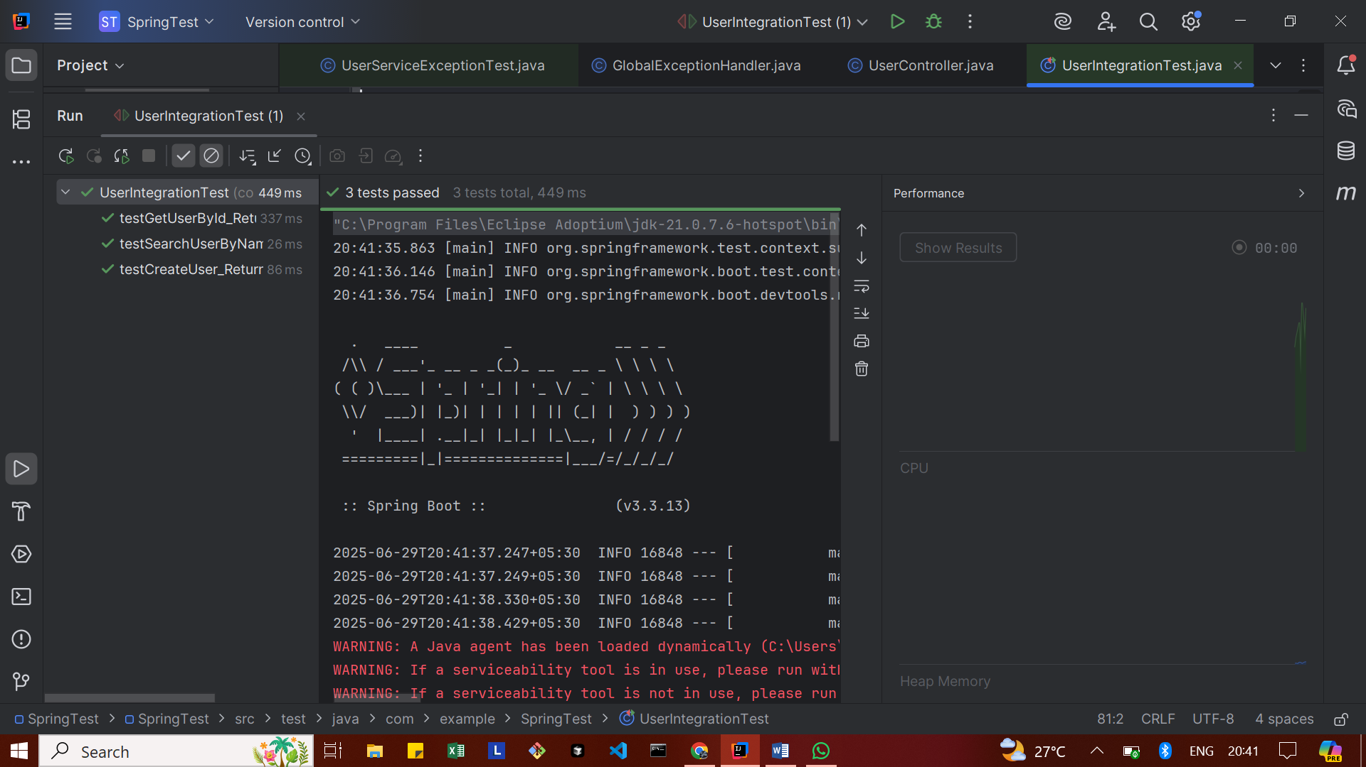

**Logging using SLF4J**

**Exercise 1: Logging Error Messages and Warning Levels**

pom.xml

<dependency>  
 <groupId>org.slf4j</groupId>  
 <artifactId>slf4j-api</artifactId>  
 <version>1.7.30</version>  
</dependency>  
  
<!-- Logback (SLF4J's logging implementation) -->  
<dependency>  
 <groupId>ch.qos.logback</groupId>  
 <artifactId>logback-classic</artifactId>  
 <version>1.5.13</version>  
</dependency>

LoggingExample.java

package com.example;  
  
import org.slf4j.Logger;  
import org.slf4j.LoggerFactory;  
  
public class LoggingExample {  
 private static final Logger *logger* = LoggerFactory.*getLogger*(LoggingExample.class);  
  
 public static void main(String[] args) {  
 *logger*.error("This is an error message");  
 *logger*.warn("This is a warning message");  
 }  
}

**OUTPUT**

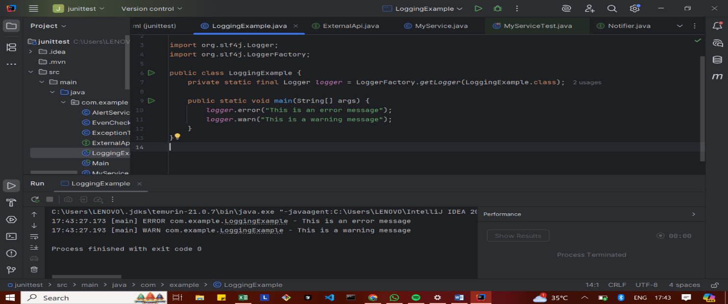

**Exercise 2: Parameterized Logging**

Pom.xml

<dependencies>

<dependency>  
 <groupId>org.slf4j</groupId>  
 <artifactId>slf4j-api</artifactId>  
 <version>1.7.30</version>  
 </dependency>  
 <dependency>  
 <groupId>ch.qos.logback</groupId>  
 <artifactId>logback-classic</artifactId>  
 <version>1.2.3</version>  
 </dependency>

</dependencies>

ParameterizedLoggingExample.java

package com.example;  
  
import org.slf4j.Logger;  
import org.slf4j.LoggerFactory;  
  
public class ParameterizedLoggingExample {  
  
 private static final Logger *logger* = LoggerFactory.*getLogger*(ParameterizedLoggingExample.class);  
  
 public static void main(String[] args) {  
 String username = "Santhiya";  
 int attempts = 3;  
  
 *logger*.info("User {} has logged in successfully.", username);  
 *logger*.warn("User {} has {} failed login attempts.", username, attempts);  
 *logger*.error("User {} triggered a security alert after {} attempts!", username, attempts);  
 }  
}

**OUTPUT**

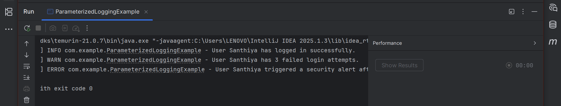

**Exercise 3: Using Different Appenders**

Pom.xml

<dependencies>

<dependency>  
 <groupId>org.slf4j</groupId>  
 <artifactId>slf4j-api</artifactId>  
 <version>1.7.30</version>  
 </dependency>  
 <dependency>  
 <groupId>ch.qos.logback</groupId>  
 <artifactId>logback-classic</artifactId>  
 <version>1.2.3</version>  
 </dependency>

</dependencies>

Logback.xml

<configuration>  
  
 <appender name="console" class="ch.qos.logback.core.ConsoleAppender">  
 <encoder>  
 <pattern>%d{HH:mm:ss.SSS} [%thread] %-5level %logger{36} - %msg%n</pattern>  
 </encoder>  
 </appender>  
  
 <appender name="file" class="ch.qos.logback.core.FileAppender">  
 <file>app.log</file>  
 <encoder>  
 <pattern>%d{HH:mm:ss.SSS} [%thread] %-5level %logger{36} - %msg%n</pattern>  
 </encoder>  
 </appender>  
  
 <root level="debug">  
 <appender-ref ref="console" />  
 <appender-ref ref="file" />  
 </root>  
  
</configuration>

AppendersExample.java

package com.example;  
  
import org.slf4j.Logger;  
import org.slf4j.LoggerFactory;  
  
public class AppendersExample {  
 private static final Logger *logger* = LoggerFactory.*getLogger*(AppendersExample.class);  
  
 public static void main(String[] args) {  
 *logger*.debug("Debug log - useful for developers");  
 *logger*.info("Info log - application started");  
 *logger*.warn("Warning log - something might be wrong");  
 *logger*.error("Error log - something went wrong!");  
 }  
}

**OUTPUT**

